Year 5 Half Term Homework
Complete a minimum of three of the following:-
Read 5 x in the week to an adult at home (10 minutes) and record it in your planner. | Prepare a lesson of your own to teach the class about an aspect of Space that you enjoy.  (Be prepared to teach it one afternoon!)
Create a timeline to show the history of space travel. Present it in any way you choose.  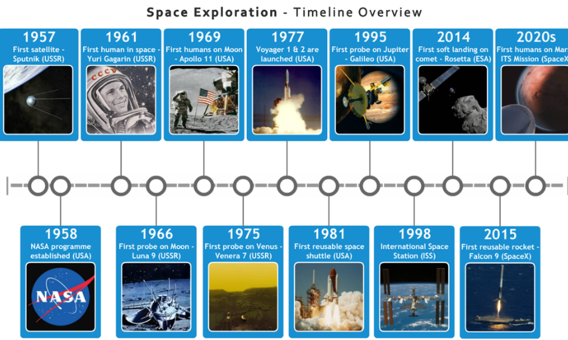 | You are going on a spaceship and can only take 10 things with you. What will you take? Either write or draw them in your suitcase.  You are going to meet some aliens on another planet. What 10 things would you take as presents for them? Draw them in a gift box.
Make a space mobile to hang in the classroom.  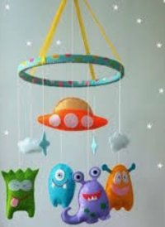 | Use TTRockstars 5 x in the week (min 10 minutes a time).
Learn 10 of the Year 5/6 spelling words really well and use them in creative sentences of your own. | Write a newspaper report about the first moon landing/ walk.

