Year 6 Autumn Term 1 Newsletter.
Welcome back after the holiday’s we hope you all had a wonderful time and enjoyed the Summer weather.

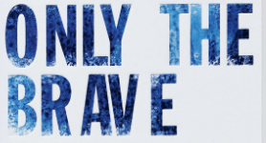

Our first topic in Year 6 is ‘Only the Brave.’ We will be exploring what bravery is and the people who had to be brave to achieve their dreams-we will be taking inspiration from these special people to help us to achieve our dreams.
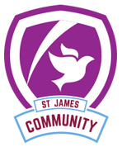
Our core value: Community
As we start a new academic year at Academy at St James we will be focusing on Community. Community is really important to us here at St James and we value the vital role it plays in our students lives. We live in a vibrant and diverse community which we want to promote and praise.
Talk Topics: Talk to your children about:
- What is a community?
- Are all communities the same?
- What does our community look like?
- What can we do for our community?
- What makes a good community?
- How do our differences make our community stronger?
- How can one individual impact on the community?
Uniform Update:
As we have moved to Year 6 all children must have a black school blazer. The children should also have: a school jumper/cardigan, a school shirt and tie, black trousers/skirt and black shoes (not trainers)

Teaching Staff:
In Bright Bees: Mrs Parker and Mrs Barker.
In Outstanding Owls: Mrs Allingham, Mrs Guest and Miss Oxley.

