**Pupil star of the week**

**CC:** Imogen- For completing every challenge that has been set with a great big smile.

**BB1:** Artjom - for completing lots of challenges at home.

**BB2:** Payton – For having a go at all the challenges set and brightening my day with some fantastic pictures.

**GG1/2:** Nabeel Aktar - for working hard across the whole curriculum

**RR1/2:** Dilshan Klair - For sharing his hard work this week! His time and effort has definitely paid off

**HH1/2:** Riley Murphy - for working hard on the work that has been set for him and making me smile with some of his answers :)

**FF3/4:** Seryn Mousa - for being productive with her work, trying her best and the teamwork of exercising with her family

**PP3/4:** Simona Vilkaite - for completing most of her work and tackling the daily physical exercises.

**FLF3/4:** Evie T- for trying so hard at work with all of her learning and for helping Henry to write! Keep it up!

**DD5:** Lucus - who has established a good timetable and routine and is completing lots of school work and uploading it to both dojo and classroom. Well done Lucus - Keep it up!

**DYD5:** Connor - for smashing home learning from the off. He has responded to feedback, furthered his learning and shown great enthusiasm. Well done Connor.

**OO6:** Lily - For completing lots of home learning and sending photographs and images of the work that she has done. Well done Lily.

**BB6:** Laiba K- for her positivity and energy. Laiba is busily completing the challenges set but also responding to comments and suggestions. A super star!

**PE:** Roksana (foxes) - For recording and filming her active adventures down at Pitty beck. We loved your footwork when getting across the beck stepping stones!

**Parent star of the week**

**CC:** Kelly Wheatley (Imogen’s Mum) For supporting all 3 girls with their home learning and for sharing it all with us. You are amazing!

**BB1:** Lucy Mithi (Ruby’s mum) For showing me the great work that Ruby is doing at home.

**BB2:** Chloe Hargreaves (Amelia’s mum) For supporting Amelia with her learning and great communication with school.

**GG1/2:** Iram Farook (Nabeel’s mum) for supporting her boys at home in all areas of learning.

**RR1/2:** Grzegorz Bugno (Szymon Bugno) for keeping his boys entertained and happy. Also for sharing videos and insights into their fun-filled days.

**HH1/2:** Geraldine Chin (Agniezcka’s mum) for uploading lots of examples of work that Agniezcka and Justine have completed.

**FF3/4:**  Irim Rehman - for supporting Ammad with his learning this week and sharing it consistently, but also understanding the need for breaks (choosing time/exercise) and positivity (rainbow/Clap for Carers).  I particularly enjoyed the written feedback and beautifully presented activities in different coloured pens! Thank you!

**PP3/4:** Alex Nakata - or her enthusiasm during CJ home exercise video

**FLF3/4:** Lucy (Riley’s mum)

For supporting Riley’s work at home and for uploading his works so I can see it

**DD5:** Shakeela Danish, who is on day 21 of isolation - for keeping that positivity and persevering with supporting Ramzi with his school work. Well done and thank you!

**DYD5:** Cheryl Fish - For being on the ball uploading all of Brendan’s working, keeping in touch and going the extra mile.

**OO6:** Danielle Hargreaves.

For going the extra mile in supporting children and staff. Thank you.

**BB6:** For all the parent’s who are supporting their children to learn. But a special shout out to Suzanne Louch for marking Zach’s maths work- well done!

**PE:** Miroslawa Nalepa (Roksana’s Mum) Thank you for getting out (safely) for your daily exercise and sharing videos of being active in our beautiful green space, Pitty Beck!

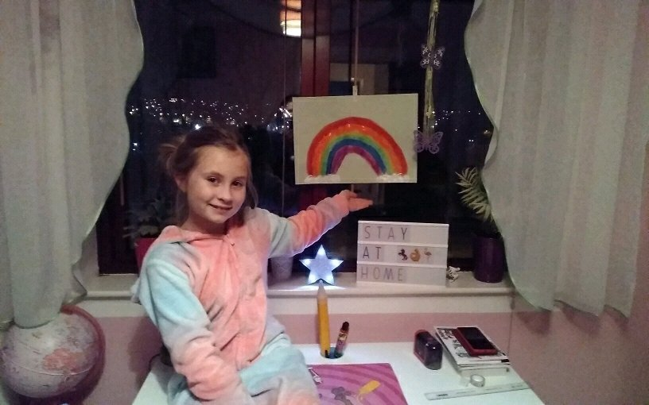



**Positive notes**

**Miss Smith:** We have awarded lots of Dojo points this week for the challenges that have been shared with us. Keep up the good work!

**Mrs Pitts:** Lots of parents are supporting their children to enable them to work at home and are sending me lots of work on dojo.

**Miss Croft:** I have been overwhelmed with the positivity and determination not only the children but also the parents have shown this week. It has really proved what a great team we are at St James.

**Mrs Gibbons:** I have had many, many emails, dojo comments and children using Google classroom to share their home learning.  Keep up the good work everyone.

**Miss Greenwood:** My highlight has been communicating with parents and my class in a different way this week. I have been blown away by the support and learning that grown-ups are doing at home. Amazing!

**Mrs Thompson:** I have had so many positive messages this week.  I am so proud of how we have all tried our best. We are all learning this new way of working and I am really proud of everyone who has uploaded some of their work.

**Miss Petty:** It is a great delight to see children saying ‘Good morning’ every morning via our GoogleDrive. A nice way to check that everyone is well!

**Mrs Wallis:**

**Mrs Brownsell:** Spending time away from school has been made so much easier by how everyone has kept in contact. From virtual meetings with Miss Petty, Mr Wallis and Mr Tolson, to chats with the Fearless Foxes and celebrating the hard work children and their adults have put in to Home Learning - it's been fantastic! I've also enjoyed Mr O'Brien's challenges and the videos being shared!

**Mrs Langley:** I am loving seeing all of the work that is being done and uploaded to our dojo and classroom. We have everything from Music to lots of edited and re-drafted writing. I am very impressed with how hard everyone in Year 5 is working. Keep it up!

**Miss Rosenberg:** It has been a lovely week in school and there have been many smiley faces. I particularly enjoyed the exploding volcanoes and Mrs Gibbon’s hula hooping!

**Mrs Parker:** I am so proud of everyone who is uploading photos of the work they are completing at home. It brightens my day to see the effort

**Mrs Allingham:** I have enjoyed working with the staff and children this week. Everyone has been so positive and supportive of everyone else. Well done everyone.

**Head Teacher’s comment**

I am so proud of all the whole community this week It has been hard but you have pulled together- I am very lucky to work in such an amazing place. We have seen so much great work coming through and some excellent photos of you and your family. Remember to take care and look after one another, You are all precious to us and we care about all of our community very much. Have a wonderful weekend and we are looking forward to next week where we see more stories, some more amazing photos and lots of positivity from our wonderful school community. Take care and God bless.

**Important notices**

**Be aware:**  
The DFE have been made aware that parents are receiving an email saying ‘As schools will be closing, if you’re entitled to free school meals, please send your bank details and we’ll make sure you’re supported’.  
This is a SCAM so please do not reply or enter your bank details. Thank you.

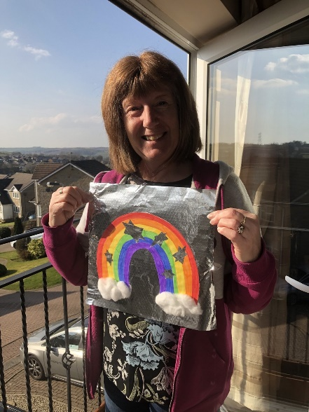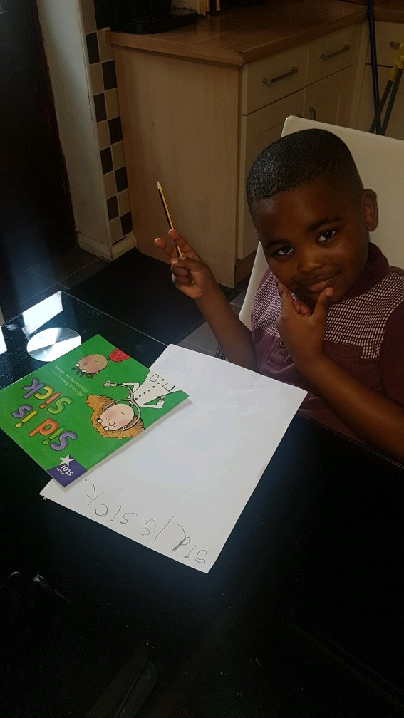

**Photos from this week**

