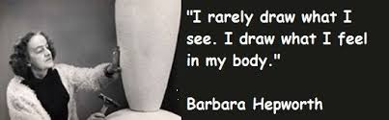



**Our vision for Art & Design**

Through our art and design curriculum our children will:

* Learn about the work of a wide range of artists, sculptors, designers and craftspeople
* Access the cultural world of art and craft via the internet, films, books, galleries, museums and visits from artists
* Learn and be able to use a unique visual language that enables them to interpret and talk about their responses to art & design
* Develop their imagination and creativity
* Learn skills and processes with a range of materials
* Be given the chance to explore the potential of a different materials and make their own discoveries
* Be encouraged to try experimental approaches
* Being excited, absorbed, and motivated by their work
* Be encouraged to reflect on their own and other’s creations with sensitivity and empathy
* Develop their awareness of different cultures and traditions
* Articulate their own ideas and develop the ability to make critical judgments
* Promoting playfulness and curiosity
* Sensitivity, empathy and intuitiveness
* Making links between unusual concepts and circumstances.
* Develop their confidence as an artist
* Develop their understanding of creative industries and careers that exist
* Understand that creating and enjoying art can used as part of a healthy and happy lifestyle

