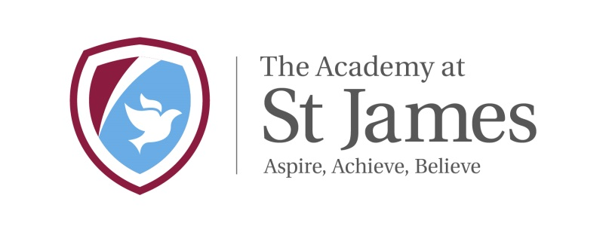

The Academy at St James

Chelwood Drive

Bradford

BD15 7YD
Telephone: 01274 777095
Headteacher: Mr Chris Tolson

CORONAVIRUS
Dear Parent/Carer,
I am writing to keep you informed of our current position with regards to the Coronavirus. At the moment there are no plans to force the closure of schools. We do not have any members of our school community with a confirmed diagnosis of the virus. We do however, have individuals who have been directed to self-isolate.
Our main priority is to remain open. In light of recent government updates, we thought it best to give you an update at the end of the school day on Tuesday 17th March.
The Prime minister has extended the self-isolation parameters to include the following:
•If one person in any household displays symptoms (a new continuous cough or a high temperature_ everyone living there must stay at home for 14 days. The 14 days stay at home advice means people should if possible, avoid leaving the house ‘even to buy food or essentials’
•As a school we are constantly being updated. We will also assure you that we will take all the necessary actions to send home anyone who becomes unwell with a new, continuous cough or a high temperature.
If any of our pupils become unwell at school they will be isolated while they wait for parents to collect them. If no symptoms are present the advice to attend their school as normal.
We are ensuring that all our pupils keep up to date with hand hygiene and please ensure you are doing all you can to further promote this at home.
As the government advice is changing all the time, we will be writing regularly to keep you updated with this unprecedented situation
What can parents do to help:
- If your child is sick, keep them off school – you are now required to self-isolate for 14 days. If you have either of the specified symptoms which are a high temperature or a new persistent cough.
- Make sure your child and family members regularly wash their hands
- Make sure you follow all guidelines to prevent the spread of the Coronavirus – our previous newsletter gave information on this.
- Make sure your contact details are up to date – we regularly send out text messages
- Make sure you are signed up to Class Dojo – if we do have to close, work for the children will be put on Dojo
- If you are a parent who works in one of our essential services: Health, police, fire brigade, teaching – please make this known to your teacher/office staff
- If you are a working parent who will really struggle if school closes - please make this known to your teacher/office staff
- Please make us aware if not having a free school meal will make things difficult. I do know this will be delicate – but we can only help if we know
- Please do not constantly ring the school office asking if we are open – you won’t believe how much time this takes up! As soon as I make a decision you will be the first to know!
- If you need to contact school please email: office@.................. and we will endeavour to respond as quickly as possible
I am in close contact with other local schools and we all share information and try to approach things in the same way. At St James we are directed by the BDAT and the government and our aim is to work together to get through this challenging time.
What we are doing as a school:
- Children have been taught how to properly wash their hands and are handwashing more frequently
- We will have only limited time spent on the carpet together
- All assemblies and collective acts of worship will be cancelled until Easter
- Trips have been postponed and so has parents evening.
- All doors within school are being kept open to avoid the need to touch door handles etc
- We have risk assessed activities in Early Years and some activities like sand, water play and play dough are suspended until further notice
- Thorough cleaning regime is in place across school
This guidance is correct as of 17.3.20 but I’m sure you will appreciate this is an ever changing picture. We will keep you up to date via text, so it is very important that you keep your contact details up to date.
We all have vulnerable individuals within our friends and families, we need to work together to keep them safe at this tricky time. Please be patient and know that we are trying to do our very best.

Mr Christopher Tolson

Headteacher

