**Curriculum- Week 2- Day 1**

**History/Art: Egyptians**

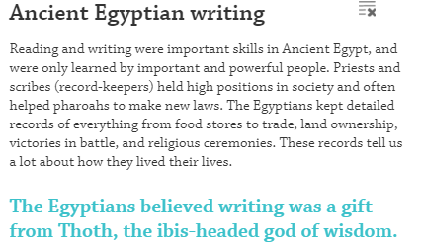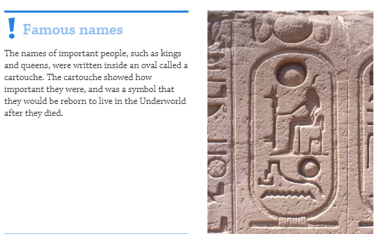

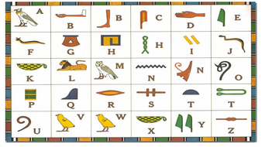

**Create your own Cartouche showing your name written in hieroglyphics**

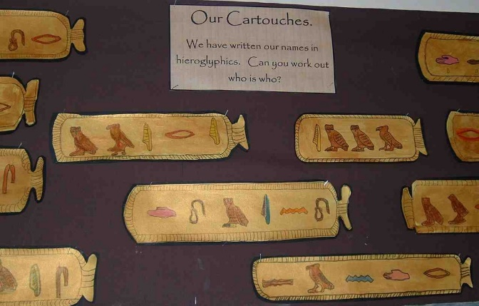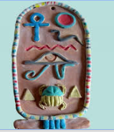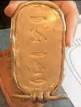

**Write a message in hieroglyphics and ask someone to decode it**