Curriculum- Week 2- Day 2
Geography: Egyptians
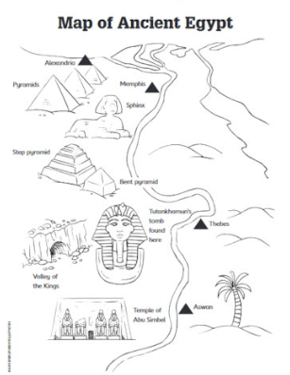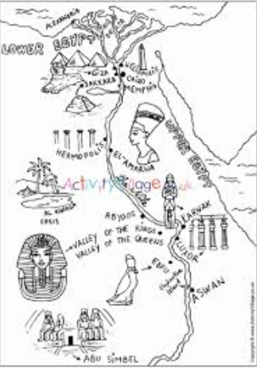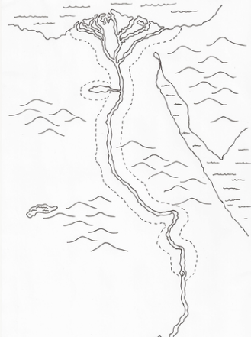
Create a map showing the key sites and landmarks of Ancient Egypt
Include:
- Images
- Labels
- Colour
Landmarks:
- Pyramids of Giza
- River Nile
- Valley of the Kings
- The Great Sphinx
- Abu Simbel
- Karnack/Luxor/Memphis/Cairo/Aswan

