Curriculum- Week 2- Day 3
History: Egyptians
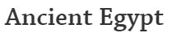
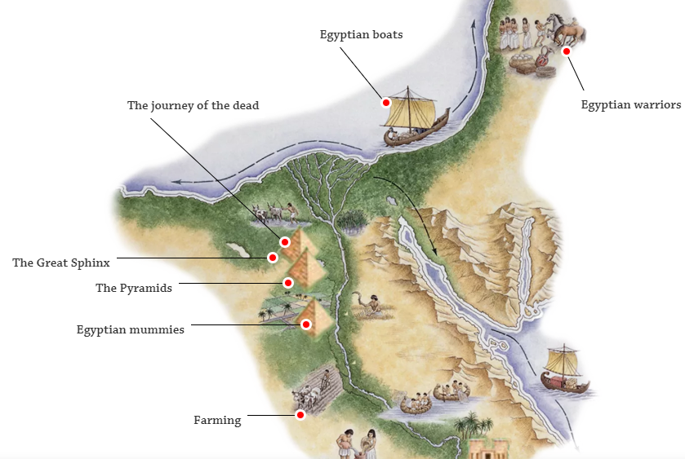
Go onto DK findout Ancient Egypt and create a non-chronological report about Ancient Egypt
Include:
- Title
- Introduction
- Subheadings (warriors, mummies, boats, pyramids, farming, temples, god and goddesses, pharaohs, writing, Valley of the Kings, The Great Sphinx, the journey of the dead)
- Diagrams and Captions

