Curriculum- Week 3- Day 1
Geography- Volcanoes
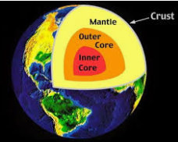
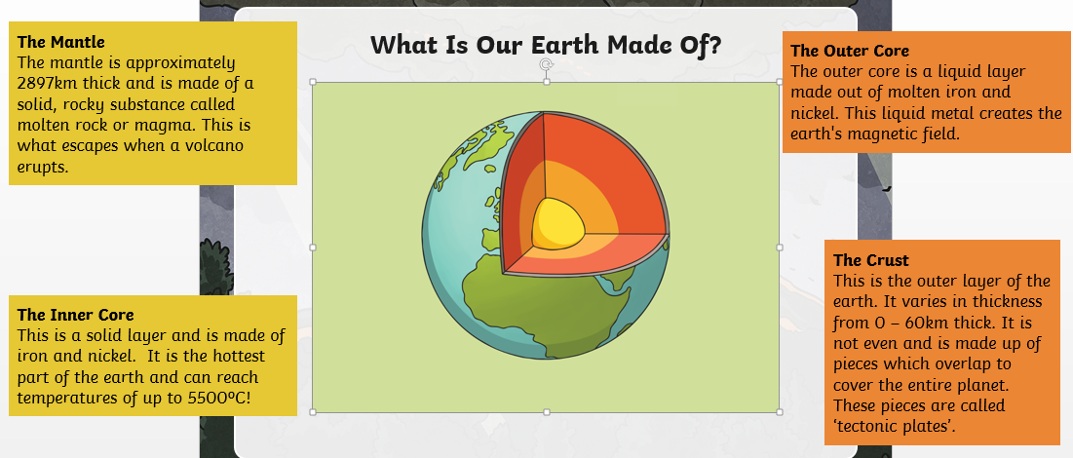
Draw and label a diagram of the Earth showing the different layers
Write a definition for each layer.

