Curriculum- Week 3- Day 5
Computing- Volcanoes
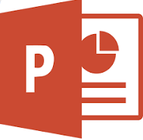
Create a PowerPoint or Non-Chronological Report about Volcanoes
Include:
- What the Earth is made up of
- Information on tectonic plates
- How they are formed
- How they erupt
- What they are made up of
- Where you find them
- Famous volcanoes and their facts
- Other information and facts

