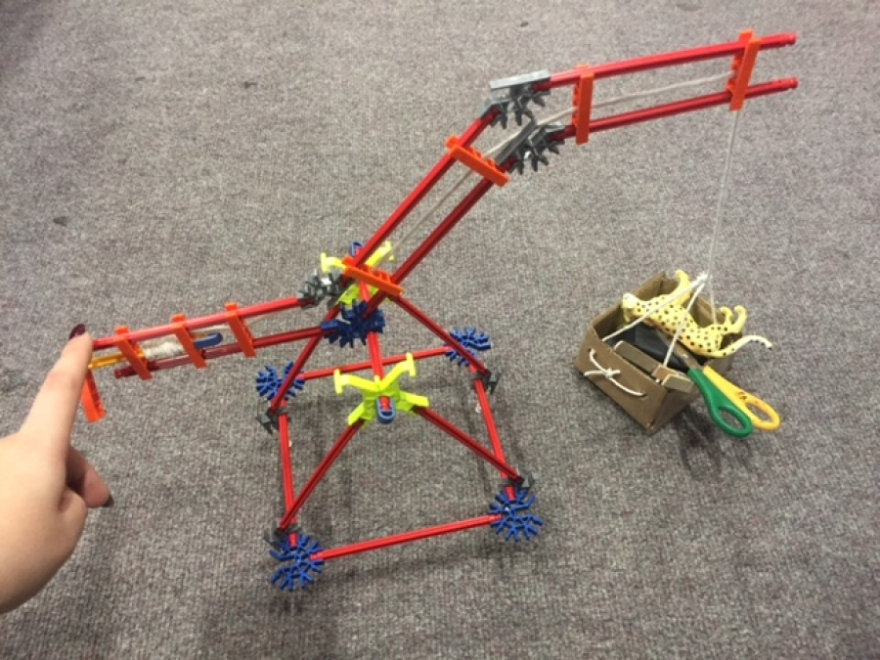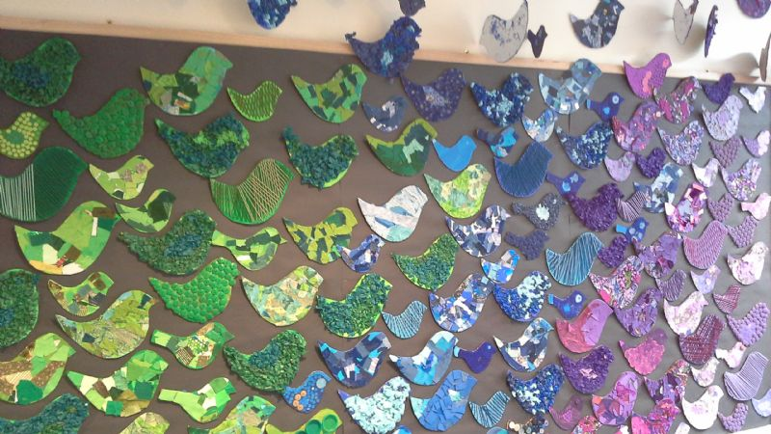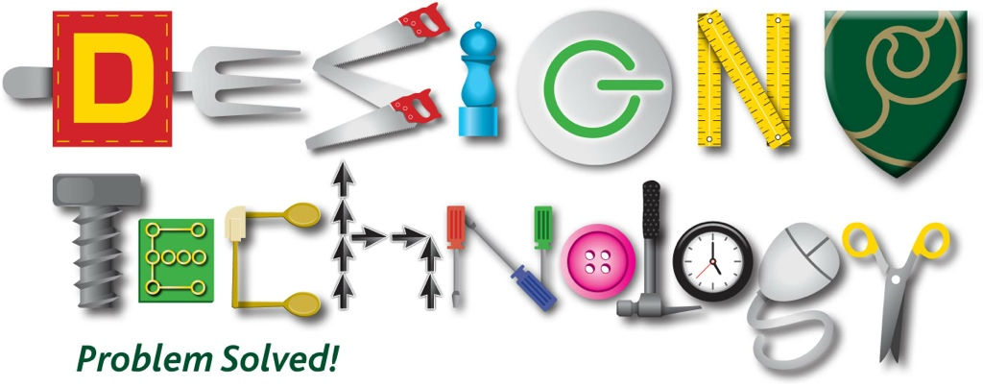

**DESIGNERS in Year 6 should be able to:**

* Talk about the product – who made it, what it is made from, purpose, when it was made, how environmentally friendly the materials are
* Evaluate the product on design, appearance and use
* Talk about the cost to make the product
* Describe the purpose of their product
* Talk about design features that will appeal to intended users
* Explain how parts of their product will work
* Develop their own design criteria and use for planning ideas
* Generate innovative ideas that meet needs of user and consider availability of resources
* Record a step by step plan for making
* Produce lists for the tools, equipment and materials they will be using
* Choose materials to use based on suitability of their properties and aesthetic qualities
* Represent ideas in diagrams, annotated sketches and computer-based programmes (where appropriate)
* Create pattern pieces and prototypes
* Choose suitable tools for making whilst explaining why they should be used Use design criteria whilst making
* Measure, mark, cut and shape materials and components accurately
* Join, assemble and combine materials and components accurately
* Demonstrate problem solving skills when encountering a mistake or practical problem
* Use finishing techniques, including skills learnt in Art accurately
* Use design criteria to evaluate product

**DESIGNERS in Year 5 should be able to:**

* Talk about the product – who made it, what it is made from, purpose, when it was made, how environmentally friendly the materials are
* Evaluate the product on design, appearance and use
* Talk about the cost to make the product
* Describe the purpose of their product
* Talk about design features that will appeal to intended users
* Explain how parts of their product will work
* Develop their own design criteria and use for planning ideas
* Generate innovative ideas that meet needs of user and consider availability of resources
* Record a step by step plan for making
* Produce lists for the tools, equipment and materials they will be using
* Choose materials to use based on suitability of their properties and aesthetic qualities
* Represent ideas in diagrams, annotated sketches and computer-based programmes (where appropriate)
* Create pattern pieces and prototypes
* Choose suitable tools for making whilst explaining why they should be used Use design criteria whilst making
* Measure, mark, cut and shape materials and components accurately
* Join, assemble and combine materials and components accurately
* Demonstrate problem solving skills when encountering a mistake or practical problem
* Use finishing techniques, including skills learnt in Art accurately
* Use design criteria to evaluate product



**Key skills overview Y1 – 6**

**DESIGN TECHNOLOGY**

**DESIGNERS in Year 4 should be able to:**

* Talk about the product – who made it, what it is made from, purpose and when it was made
* Evaluate the product on design and use
* Gather information about what a group or people want from a product
* Describe the purpose of their product
* Talk about design features that will appeal to intended users
* Explain how parts of their product works
* Develop their own design criteria and use for planning ideas
* Generate realistic ideas that meet needs of user and consider availability of resources
* Order the main stages of making
* Choose materials to use based on suitability of their properties
* Represent ideas in diagrams and annotated sketches
* Create pattern pieces and prototypes
* Choose suitable tools for making whilst explaining why they should be used Use design criteria whilst making
* Measure, mark, cut and shape materials and components with some accuracy
* Join, assemble and combine materials and components with some accuracy
* Use finishing techniques, including skills learnt in Art with some accuracy
* Use design criteria to evaluate product – identifying both strengths and areas for development
* Consider the views of others, including intended user, whilst evaluating product

**DESIGNERS in Year 3 should be able to:**

* Talk about the product – who made it, what it is made from, purpose and when it was made
* Evaluate the product on design and use
* Gather information about what a group want from a product
* Describe the purpose of a product
* Explain how parts of their product works
* Generate realistic ideas that meet needs of user
* Share and discuss ideas with others
* Order the main stages of making
* Choose materials to use based on suitability of their properties
* Represent ideas in diagrams and annotated sketches
* Create pattern pieces and prototypes
* Choose suitable tools for making whilst explaining why they should be used Use design criteria whilst making
* Measure, mark, cut and shape materials and components with some accuracy
* Join, assemble and combine materials and components with some accuracy
* Use finishing techniques, including skills learnt in Art with some accuracy
* Use design criteria to evaluate product – identifying both strengths and areas for development
* Consider the views of others, including intended user, whilst evaluating product

**DESIGNERS in Year 2 should be able to:**

* Talk about a product, who it is for, how it works and how it is used
* Talk about where you might find a product and what it is made from
* Express an opinion about a product
* Explain what product they will be designing and making
* Explain who their product will be used by
* Describe what their product will be used for & how it will work
* Talk about the steps for making their product
* Talk about and draw their ideas
* Choose materials to use based on their suitability
* Measure, mark, cut and shape materials/components
* Join, assemble and combine materials/components
* Use finishing techniques e.g. art skills
* Talk about their design and what they’ve made
* Make simple judgements about how the product met their design ideas
* Suggest how their product could be improved

S

**DESIGNERS in Year 1 should be able to:**

* Talk about a product and who it is for
* Talk about how a product works and how it is used
* Explain what product they will be designing and making
* Explain who their product will be used by
* Describe what their product will be used for
* Talk about the steps for making their product
* Talk about and draw their ideas
* Choose suitable tools and equipment for making their product
* Measure, mark, cut and shape materials/components
* Join, assemble and combine materials/components
* Talk about their design and what they’ve made
* Make simple judgements about how the product met their design ideas