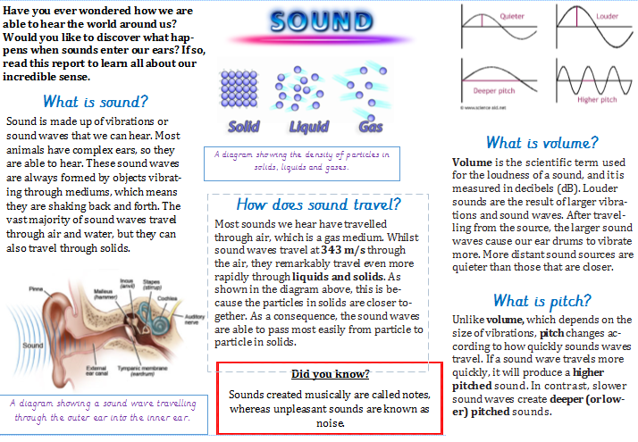
What to do:
- Read the Sound non-chronological report in your head and practice reading it out loud.
Read with expression, and remember to pause at punctuation (short pause at commas and a longer pause and breath at full stops).

- Hunt for the non-chronological report features!
Identify and write down examples of a title, heading, caption, generaliser, topic sentence, technical vocabulary, causal/contrasting conjunctions and comparative language. (see the next sheet for some help on what some of these features are).

- Answer the questions about the report in full sentences!
Remember to:
SKIM – make sure you know what the question is asking, identify key words in the question and have a quick look over the text to find the relevant paragraph.
SCAN – use your finger as you read to find key words and phrases in the text.
CLOSE READING – once you have found a key word, read the sentence (and the ones before and after, if needed) to find the answer.

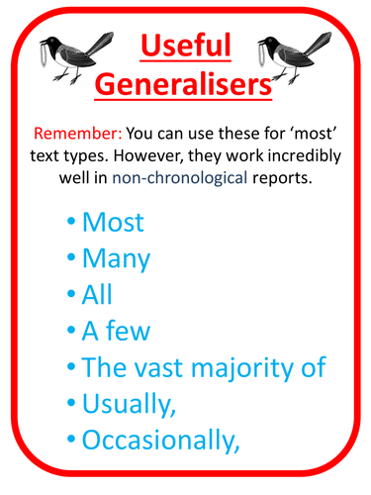
Comparative language notices what is the same and what is different about two or more nouns.

e.g. The sun is brighter than the moon.
Our library is quieter than the playground.
Dancing is more fun than washing up.
Generalisers tell the reader how often something happens or how common it is.

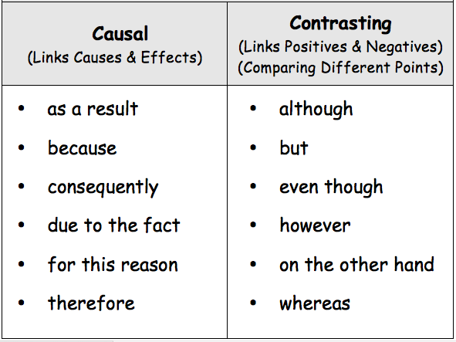

Technical language is specific vocabulary about a particular subject. Examples:
denominator (bottom number in a fraction)
molar (type of tooth at the back of human mouths)

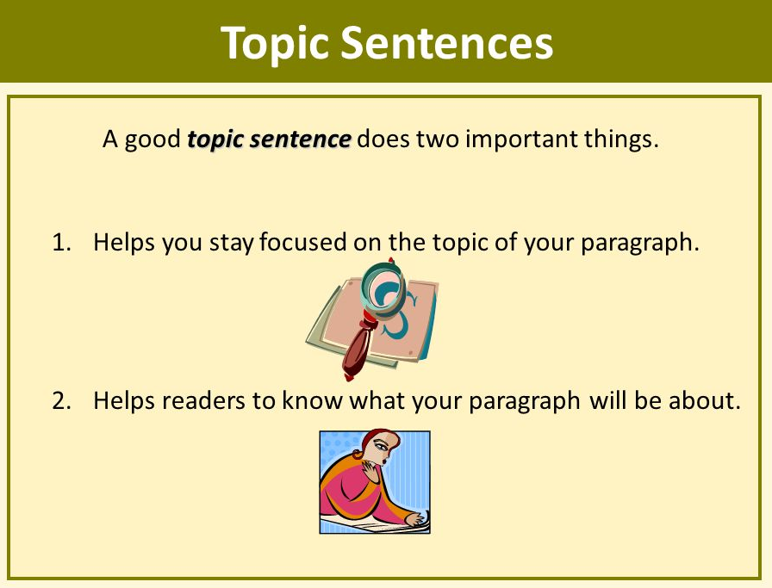
Topic sentences – these are usually at the start of a paragraph in a non-fiction text, and explain the main idea in that paragraph.

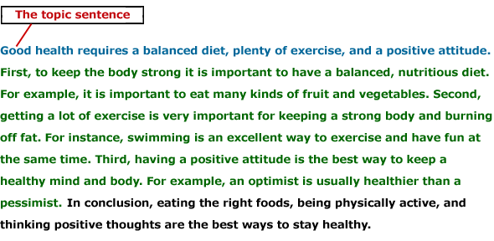

Questions
- How are most animals able to hear?
Remember to answer in full sentences! E.g. Most animals are able to hear, because…
- Which mediums do the vast majority of sound waves travel through?

- What does the diagram in the middle show the reader about particles?

- How quickly can sound waves travel through air?
True or false: sound waves travel more quickly through air (gas), than liquids and solids.

- What is the technical term given to sounds made musically?

- Fill in the missing word: Pitch changes depending on how ____________ sound waves travel.

- What do larger sound waves do once they have entered our ears?
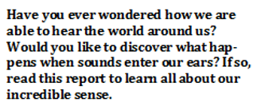
- This is the introduction to the Sound non-chronological report.
Why do you think it might encourage someone to read the report?

