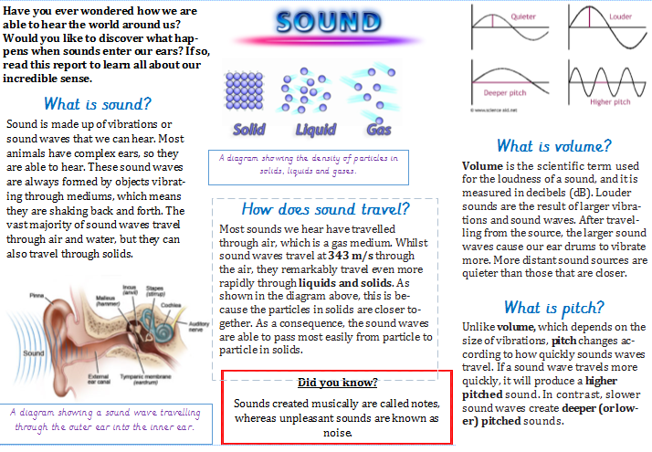
What to do:
- Write down as many facts as you can about sound/hearing in 2mins!

- Read the Sound non-chronological report in your head and practice reading it out loud – were your fact accurate?
Read with expression, and remember to pause at punctuation (short pause at commas and a longer pause and breath at full stops).

- Remind yourself of the meaning and examples of the different features in a report:
generaliser, topic sentence, technical vocabulary, causal/contrasting conjunctions and comparative language.

- Sort the word and sentences into the right features groups.
Challenge – create your own example sentences for the feature groups.
Choose one person, object, hobby etc. to write all your own sentences about.
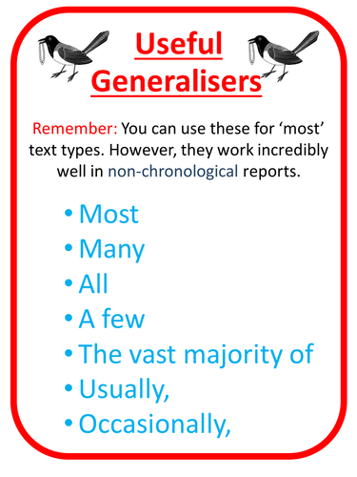
Comparative language notices what is the same and what is different about two or more nouns.

e.g. The sun is brighter than the moon.
Our library is quieter than the playground.
Dancing is more fun than washing up.
Generalisers tell the reader how often something happens or how common it is.

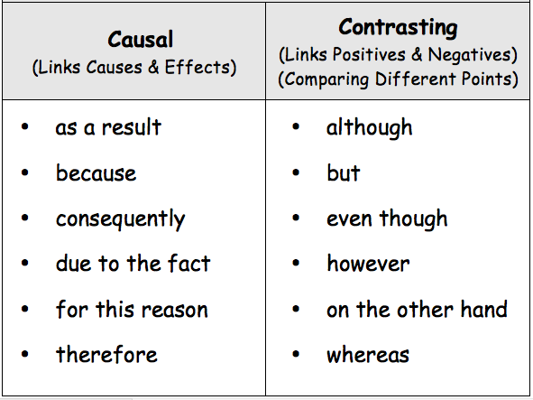

Technical language is specific vocabulary about a particular subject. Examples:
denominator (bottom number in a fraction)
molar (type of tooth at the back of human mouths)

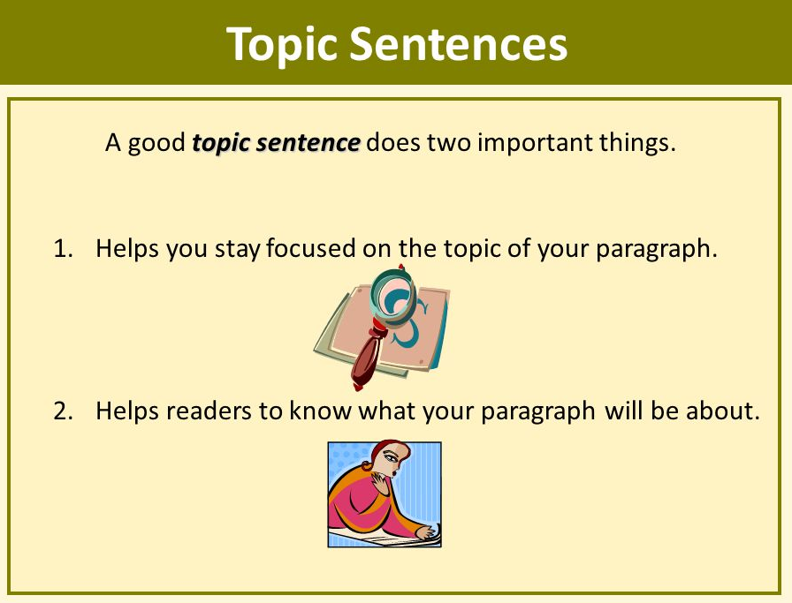
Topic sentences – these are usually at the start of a paragraph in a non-fiction text, and explain the main idea in that paragraph.

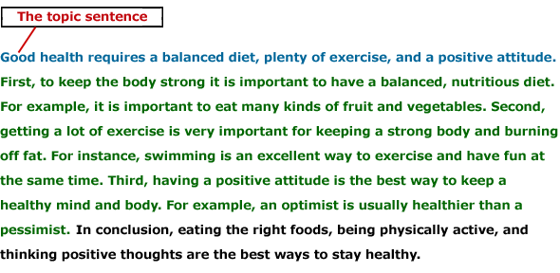

Generalisers | Topic sentence | Technical vocabulary
Causal conjunction | Contrasting conjunction | Comparative language

As a result of his injury, the basketballer will not be able to play the next match.

Mammals have fur and opposable thumbs, whereas fish have scales and fins.

Germany invaded Poland in 1939, and Britain consequently declared war.

After being crushed by molars and broken down by saliva, food travels down the oesophagus.

The vast majority of people prefer summer, because they enjoy warm sunshine.

Buckingham Palace is located in London, and is the main accommodation for the Queen.

Usually I wear wellies, when I know the field I am going to walk on might be muddy.

The boy’s air raid shelter squatted lower than could be seen by distant

