Time Travelling with a Hamster
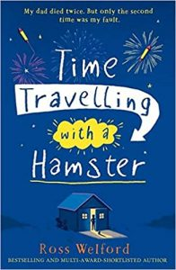
p. 12- 14
1. Why are there beds and a toilet in the cellar? What was the room used for? Explain with evidence from the text.
2. “The inside of the mug is all furred up with ancient mould.” Why? What’s happened to the mug?
3. What are your thoughts about the time machine? How will it work? What will happen next?

Draw what you read:
Draw a picture of the cellar using the description. Label what you absolutely know and write your thoughts/ inferences in thought bubbles.

