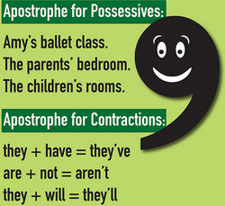
Add apostrophes to the sentences below to correct them:

Miss Pettys class is called the Flourishing Flamingos.

During Blackout, lights werent allowed on once the siren had sounded.

A humans ear is made of the pinna (outer ear), ear canal (middle ear) and inner ear, which includes the ear drum and auditory nerves.

Once you have added the apostrophes, label why the apostrophe is needed. If it is a contraction, which two words have been contracted? If it is an apostrophe for possession, what belongs to who in the sentence?

This introduction uses the common method of:
- two questions
- an If so statement
Introduction
This needs to draw in the reader and make them want to read the whole report. You might want to include more information that the example above, but remember not to go into too much detail in your introduction – that is what the headings/paragraphs are for.

Can you work out from the introductions written below, what the reports might be about?
Have you noticed a courageous girl in the news? Would you like to find out more about her ambitious plans to save the world? If so, read this report about one of the most inspiring figures working on climate change right now.
Have you ever wondered where children aged 4-11 are educated in Allerton? Have you wanted to know which community wears a burgundy and light blue uniform? If so, continuing reading to discover more about the best school in Bradford!
Now, write your own non-chronological report introductions using the examples as guides.
It could be about your favourite place, toy, person - you choose!

