Time Travelling with a Hamster
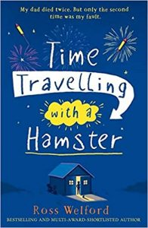
p. 17-19

- How does the narrator feel about their dad dying and mum remarrying? How can you tell?
- Why do some people have to wait until their 31 for their once in a lifetime birthday?

Role on the wall – Albert
What do you know about Albert already?
Outside – appearance
Inside – family/ relationships/ characteristics

