Apostrophes

Yesterday, you edited my sentences with apostrophes. Today, I’d like you to write your own sentences – at least 2 sentences using apostrophes for possession and 2 sentences using apostrophes for contraction.

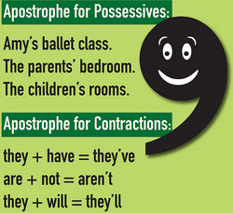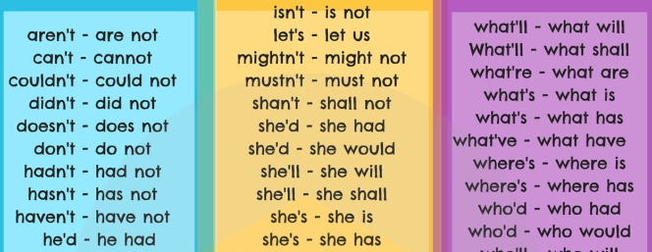

Once you have added the apostrophes, label why the apostrophe is needed. If it is a contraction, which two words have been contracted? If it is an apostrophe for possession, what belongs to who in the sentence?

Silly Questions!
Today, we are going to practise using our generalisers, comparative language and causal/contrasting conjunctions in a creative way. This will then help us to use that vocabulary in our non-chronological report paragraphs.

Below is an example of using these features, with colour-coding. Use the other silly questions or create your own for your own sentences. Try to colour-code them too, if possible.

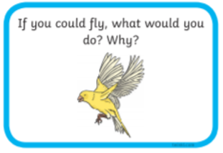
Although being able to fly sounds really appealing, what I would do depends on how I would cope with heights! For this reason, I would start by being more careful than the vast majority of birds, which race up into the sky.
Once I got used to the heights, I think I would occasionally fly to visit my parents, who live three hundred miles away. On the one hand, it might be quicker than any other mode of transport. On the other hand, flying might be more tiring than I think!
How amazing it would be to serenely glide through the sky, though!

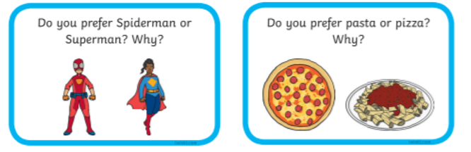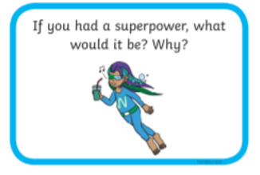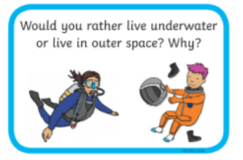

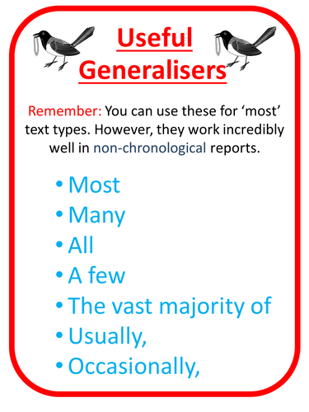
Comparative language notices what is the same and what is different about two or more nouns.

e.g. The sun is brighter than the moon.
Our library is quieter than the playground.
Dancing is more fun than washing up.
Generalisers tell the reader how often something happens or how common it is.

