Time Travelling with a Hamster
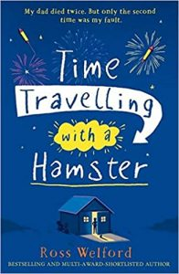
p. 20-22

Grandpa Byron – What do we know about him?
3:2:1
Write 3 things that you definitely know about him.
Write 2 things you don’t know yet.
Write 1 question that you would like answering.

Prediction:
What do you think dad has written in the letter? Explain with evidence.
Why do you think he has to wait 16 hours before opening the letter?

