Time Travelling with a Hamster
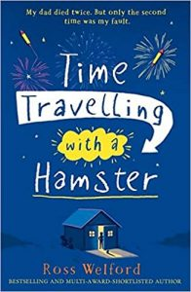
p. 23 – 26

Did this chapter answer your question about Grandpa?

True/ False/ Prove it
Answer these with “True” or “False” and then prove it with evidence from the text. What makes you believe they are true/false?

- Albert has a good relationship with his Grandpa Byron.
- Grandpa Byron is a genius and remembers things well.
- Albert’s grandma will be one of the main characters in the book.
- Grandpa Byron has always lived in England.

