English – Week 2 – Day 3
Creative Writing
Egyptian Theme
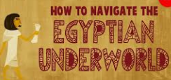

Read the information below and explain what the Egyptian’s believed about the afterlife

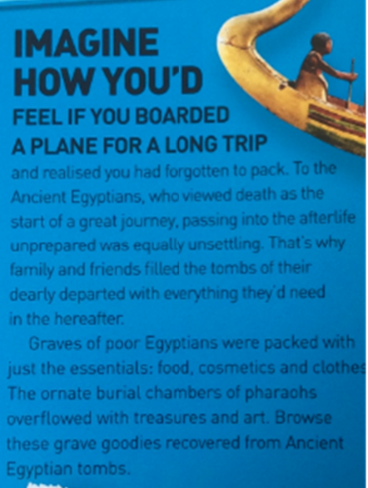
What did Egyptian’s believe about the afterlife?
_________________________________________________________________________________________________________________________________________________________________________________________________________________________________________________________________________________________________________________________________________________________________________________________________________________________________________________________________________________________________

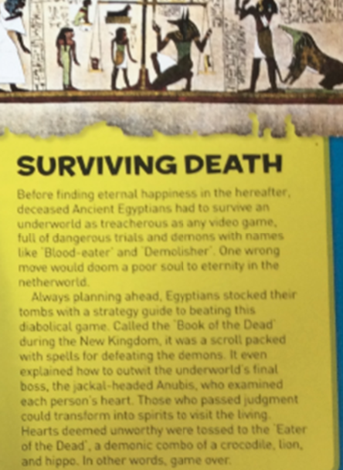
What did Egyptian’s believe about the underworld?
_________________________________________________________________________________________________________________________________________________________________________________________________________________________________________________________________________________________________________________________________________________________________________________________________________________________________________________________________________________________________

Now use that information and other information which you can research to create a survival guide for the Egyptian Afterlife
Below in an example which you can use.
