English – Week 2 – Day 5
Creative Writing
Egyptian Theme
Imagine you have been exploring Ancient Egypt.
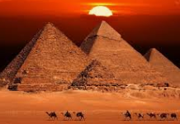
Write a postcard home explaining and describing everything which you have seen and done.
Places you could visit:
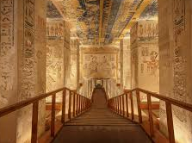
- Pyramids of Giza
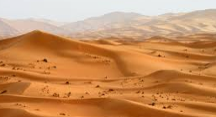
- The Valley of the Kings
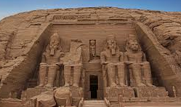
- The Sahara Desert
- Temples and Tombs
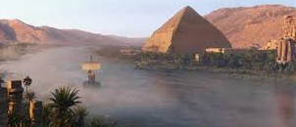
- The River Nile.
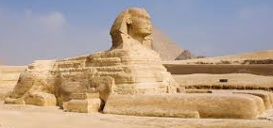
- The Great Sphinx

