English- Week 3- Day 1
Ancient Rome Theme
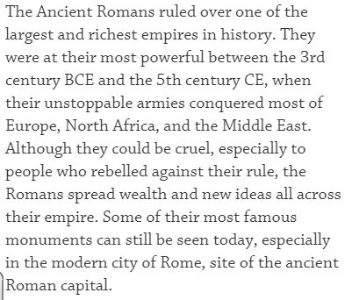
Use the link below (or type in dkfindout ancient rome) to create a non-chronological report about Ancient Rome.
https://www.dkfindout.com/uk/history/ancient-rome/
Include:
- Introduction
- Subheadings (The Roman People, The Colosseum, Gladiators, The Roman Army, Pompeii, Roman God and Goddesses)
- Images/Diagrams and Captions

