English- Week 3- Day 2
Ancient Rome Theme
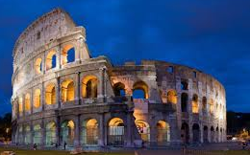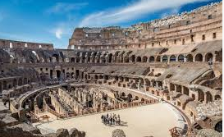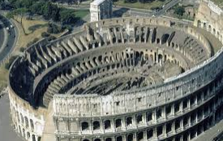
Write a detailed setting descritpion about The Colosseum
Include:
- Fronted adverbials
- Expanded Noun Phrases
- Relative Clauses
- Prepositional Phrases
- Personification
- Verbs and Adverbs for detail

