English- Week 3- Day 3
Ancient Rome Theme
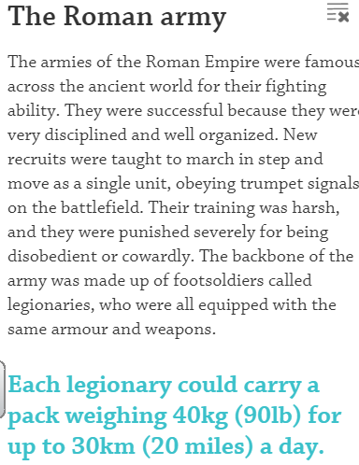
Read the information below and use the links (https://www.dkfindout.com/uk/history/ancient-rome/roman-army/ https://www.bbc.co.uk/bitesize/topics/zwmpfg8/articles/zqbnfg8) to create an instruction guide on how to be a Roman solider.
Include:
- Introduction
- Equipment list
- Method Steps
- Conclusion
- Diagram and label of a Roman Soldiers Outfit and weapons (use the link for this)
Information:
- Only men could become Roman soldiers. Women were not allowed to join.
- In order to become a Roman soldier the men needed to over the age of 20 so that they could join one of the Roman Army legions.
- Minimum of 25 years in the army.
- Roman soldiers were not allowed to get married until they completed their service.

Roman Soldier Training
The Roman Army were incredibly well trained and organized, performing drills every single day. Tactically, they were also very precise and the organization, leadership and logistics were also practiced often. Roman soldiers needed to be physically fit and strong above all else, and they needed to be able to take instructions and follow them without hesitation or question.
- Roman soldiers were expected to be able to march about 36km (24 miles) a day, wearing full armor and carrying their weapons and equipment. They need to be able to complete this march in around 5 hours.
- Soldiers also trained to swim, fight, build bridges, set up camp and cope with any injuries together as a unit.
- Roman soldiers would practice hand-to-hand combat with wooden swords, spears and shields. These were deliberately much heavier than the weapons and equipment used in real battle to train them to fight through tiredness.
- Roman soldiers are famous for their discipline in battle and the ability to take orders. They would train in formations and lines that they also used in battle. An organized army is often the most successful.
- Some Roman soldiers received specific training for a certain discipline. Some trained to become expert archers, some trained to use onagers – which were giant catapults, some used large crossbows known as ballistas, and the army also had cavalry units called Equites. These were men rich enough to have horses and more expensive weapons to train with.

Roman Weapons, Armour and Equipment
- Roman soldiers wore helmets and body protection in battle - the soldier usually brought their own equipment.
- The Hastati were the first line of Roman soldiers and they wore breastplates called cuirass and occasionally chainmail, which they called lorica hamata.
- The second line of soldiers, called principes, were often richer and always wore chainmail, although they also wore cheaper breastplates as well.
- Both the Hastati and principes used a gladius sword in close combat battle. The sword was short, around 2 feet in length, and was useful for stabbing enemies.
- Roman soldiers also carried two pila. These were short spears which could be thrown like a javelin.
- The third line of soldiers were called the Triarii, and they had a two meter long spear – known as a hasta.
- All legionaries had a large rectangular shield, the scutum, which had rounded corners to fit around the body of the soldier.
Example of an instruction guide
Instructions: How to Become a Roman Soldier
Are you amazed by the strength of the Roman Army? Have you ever considered becoming a Roman soldier? If so, read on...
What You Need:
• armour
• weapons
• a teacher
• a stretching machine
• camping kit
What You Do:
1) First, ensure you are at least 1.75 metres tall. If you aren’t, don’t panic! Instead, gradually stretch yourself using the ‘Delux Roman Soldier Stretching Machine’.
2) After that, persuade a teacher to teach you to read and write Latin.
3) Then, consult an optician to ensure you can see your enemies well.
4) Bravely sign up to join the Roman Army.
5) Keep fit by participating in a daily 18-mile march, carrying full camping kit at all times.
6) Next, taking care not to lacerate yourself, build muscle through daily sword practice.
7) Finally, prepare yourself for harsh punishments, remembering not to cry (the army don’t like wimps!)
HANDY HINT: You may want to invest in several packets of tissues!
Follow these instructions carefully and you will become a rampaging Roman soldier. You are now fully equipped to go into battle. Good luck!

