English- Week 3- Day 5
Ancient Rome Theme
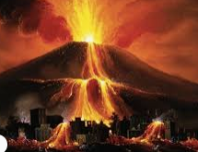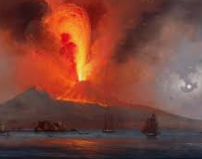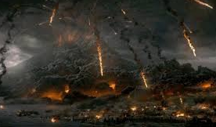
Write a letter to your family in Rome explaining and describing what happened in Pompeii when the Mount Vesuvius erupted.

