English- Week 3- Day 5
Ancient Rome Theme
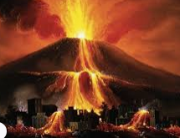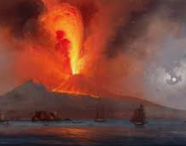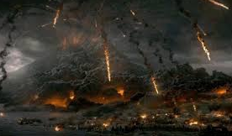
Write a letter to your family in Rome explaining and describing what happened in Pompeii when the Mount Vesuvius erupted.
Include:
- What you were doing?
- What it looked like?
- What happened to you and others in the town?
- What did you do to escape?
- How do you feel?
- What are you going to do now?

