English home learning

Your child should be practising:
- All phonic sounds taught so far.
- All red words taught so far.
- Read words using phonics sounds.
- To write labels using phonic sounds.
- Daily reading.

Useful links:
https://www.phonicsplay.co.uk/Phase2Menu.htm
https://www.topmarks.co.uk/english-games/5-7-years/letters-and-sounds
http://www.letters-and-sounds.com/phase-2-games.html
https://www.youtube.com/results?search_query=geraldine+the+giraffe+

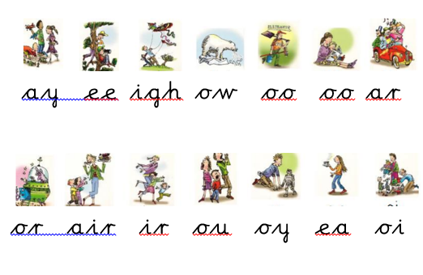

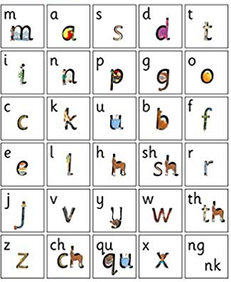

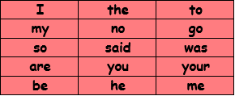

Read Write Inc. Green Words, Set 1
Word  Time  1 | Read | Spell | Word  Time  2 | Read | Spell | Word  Time  3 | Read | Spell | Word  Time  4 | Read | Spell
at |  |  | an |  |  | bad |  |  | fan
dad |  |  | and |  |  | bin |  |  | fat
mad |  |  | dog |  |  | can |  |  | fish
mat |  |  | dig |  |  | cat |  |  | fun
sad |  |  | gap |  |  | cot |  |  | had
sat |  |  | got |  |  | cup |  |  | hen
 |  |  | in |  |  | kit |  |  | hit
 |  |  | it |  |  | mud |  |  | let
 |  |  | on |  |  | up |  |  | lip
 |  |  | pan |  |  | back |  |  | log
 |  |  | pin |  |  | kick |  |  | met
 |  |  | sit |  |  | lock |  |  | sack
 |  |  | tip |  |  |  |  |  | set
 |  |  | top |  |  |  |  |  | ship
 |  |  |  |  |  |  |  |  | shop

Word  Time  5 | Read | Spell | Word  Time  6 | Read | Spell | Word  Time  7 | Read | Spell
jam |  |  | bang |  |  | bell
jet |  |  | box |  |  | best
jog |  |  | chat |  |  | blob
rat |  |  | chin |  |  | blip
red |  |  | chop |  |  | brat
run |  |  | fox |  |  | clip
sock |  |  | fix |  |  | dress
vet |  |  | quit |  |  | drip
web |  |  | quiz |  |  | drop
wet |  |  | sing |  |  | flag
win |  |  | six |  |  | flop
wish |  |  | thick |  |  | frog
yap |  |  | thin |  |  | from
yes |  |  | thing |  |  | gran
yum |  |  | this |  |  | grin
 |  |  | wing |  |  | mess
 |  |  | zap |  |  | pram
 |  |  | zip |  |  | prop
 |  |  |  |  |  | skip
 |  |  |  |  |  | slid
 |  |  |  |  |  | slip
 |  |  |  |  |  | test
 |  |  |  |  |  | thing
 |  |  |  |  |  | think
 |  |  |  |  |  | trip
 |  |  |  |  |  | well
 |  |  |  |  |  | wink

Cursive Lower Case Letters

