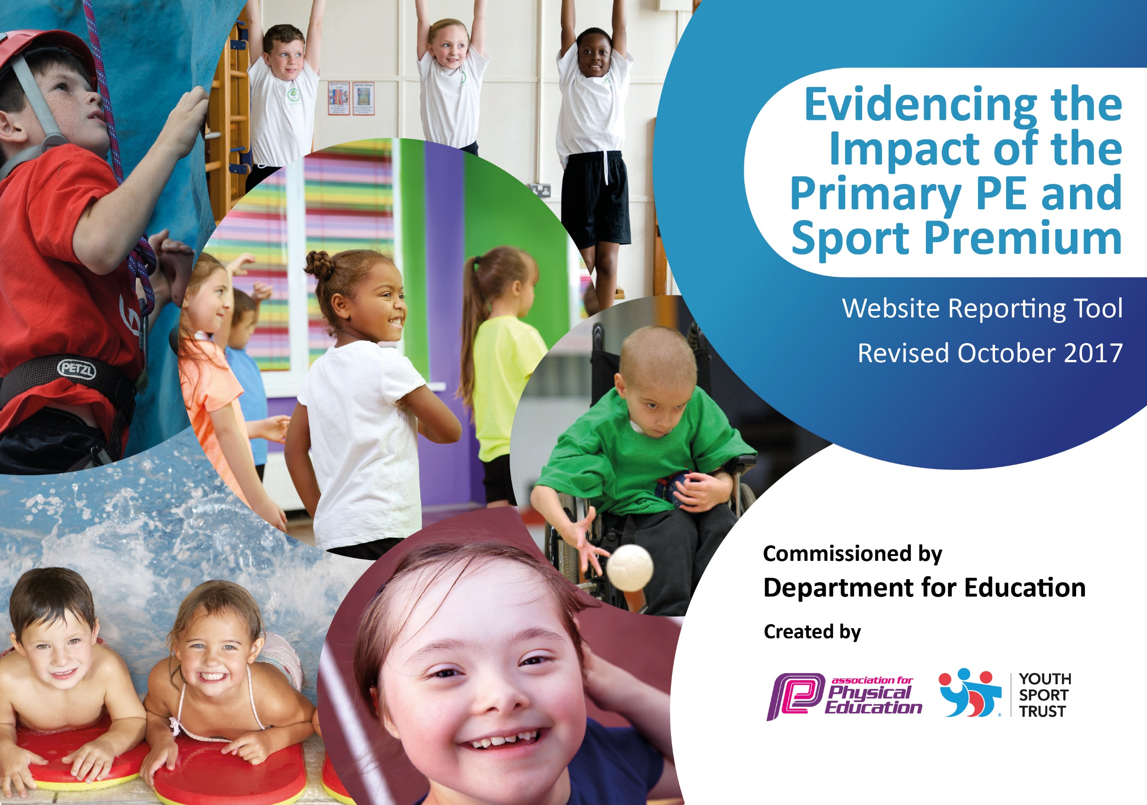

Schools must use the funding to make additional and sustainable improvements to the quality of PE and sport they offer. This means that you should use the Primary PE and Sport Premium to:

- develop or add to the PE and sport activities that your school already offers
- build capacity and capability within the school to ensure that improvements made now will benefit pupils joining the school in future years

Please visit gov.uk for the revised DfE guidance including the 5 key indicators across which schools should demonstrate an improvement. This document will help you to review your provision and to report your spend. DfE encourages schools to use this template as an effective way of meeting the reporting requirements of the Primary PE and Sport Premium.

We recommend you start by reflecting on the impact of current provision and reviewing the previous spend.
Under the Ofsted Schools Inspection Framework, inspectors will assess how effectively leaders use
the Primary PE and Sport Premium and measure its impact on outcomes for pupils, and how effectively governors hold them to account
for this.

Schools are required to publish details of how they spend this funding as well as on the impact it has on pupils’ PE
and sport participation and attainment.
We recommend regularly updating the table and
publishing it on your website as evidence
of your ongoing review into how you are using the money
to secure maximum, sustainable impact. To see an example of how to complete the table please click HERE.

Support for review and reflection - considering the 5 key indicators from DfE, what development needs are a priority for your setting and your students now and why? Use the space below to reflect on previous spend, identify current need and priorities for the future.

Key achievements to date: | Areas for further improvement and baseline evidence of need:
An inprovement in the % of pupils swimming in all areas. This will get even better in 2020 with:  25m 77.27%  Range 81.82%  Self rescue 18.18%  Teachers are delivering P.E to their own class and pupils have been accessing competitions on a more regular basis.  Linked with Sport England with £30,000 worth of funding to support physical activity. | - Develop a more physically active curriculum to support pupils of all abilities  - Support and train staff with a high level of CPD to strengthen understanding and subject knowledge.  - Work with Sport England to look a holistic picture of pupil physical activity and engage parents.

Meeting national curriculum requirements for swimming and water safety | Please complete all of the below:
What percentage of your Year 6 pupils could swim competently, confidently and proficiently over a distance of at least 25 metres when they left your primary school at the end of last academic year? | 58.3%
What percentage of your Year 6 pupils could use a range of strokes effectively [for example, front crawl, backstroke and breaststroke] when they left your primary school at the end of last academic year? | 60.4%
What percentage of your Year 6 pupils could perform safe self-rescue in different water-based situations when they left your primary school at the end of last academic year? | 10%
Schools can choose to use the Primary PE and Sport Premium to provide additional provision for swimming but this must be for activity over and above the national curriculum requirements. Have you used it in this way? | Yes/No

Action Plan and Budget Tracking
Capture your intended annual spend against the 5 key indicators. Clarify the success criteria and evidence of impact that you intend to measure to evaluate for students today and for the future.

Academic Year: 2017/18 | Total fund allocated: £18640 | Date Updated:
Key indicator 1: The engagement of all pupils in regular physical activity – Chief Medical Officer guidelines recommend that primary school children undertake at least 30 minutes of physical activity a day in school |  |  |  | Percentage of total allocation:
 |  |  |  | %
School focus with clarity on intended impact on pupils: | Actions to achieve: | Funding allocated: | Evidence and impact: | Sustainability and suggested next steps:
To continue to improve the provision and access for EY and KS1 pupils  To ensure pupils are physical active regularly in the school day  To develop the quality of teaching of PE to ensure pupils receive high quality teaching  To develop and improve the quality if resources to support pupils play in all areas of school life | Sports coach timetabled sessions to work to develop core skills – balance bikes, ball skills, running etc.  Review physical activity  Year 1-5 take part in a research project measuring physical activity  Work with Sport England to develop an action plan to develop physical activity across the school  Purchase specialist equipment to enable children to participate in wider range of activities | £5k staffing costs  £940  £2k
Key indicator 2: The profile of PE and sport being raised across the school as a tool for whole school improvement |  |  |  | Percentage of total allocation:
 |  |  |  | %
School focus with clarity on intended impact on pupils: | Actions to achieve: | Funding allocated: | Evidence and impact: | Sustainability and suggested next steps:
Work to achieve sports award | Complete the actions and requirements to apply for the sports award |  | Specialist Sports coach employed.  Games training for all staff raised the profile.  Regular Assembly contributions about sports events and competitions.  End of Year sports Trophy for achievement and sportsmanship created.  Special Visitors such as Jenny Wallwork (Sponsored event)  Silver award for achieved - | Continue to meet the criteria for the silver award.  More training for all staff including outdoor education.

Key indicator 3: Increased confidence, knowledge and skills of all staff in teaching PE and sport |  |  |  | Percentage of total allocation:
 |  |  |  | %
School focus with clarity on intended  impact on pupils: | Actions to achieve: | Funding  allocated: | Evidence and impact: | Sustainability and suggested  next steps:
CPD for teachers on key skills and warm up activities  CPD for sports coach | Teachers will start lessons more effectively by incorporating key skills and fitness programmes into preparation for the main session  Training and support provided for sports coach by linking to another school for professional development | £200  £500 | Specialist sports coach employed to support staff.  CPD was delivered and had a positive impact on teachers’ lessons. They have a broader range of games and activities to work with in their sessions.  Not yet started | Further staff development to build on what has already been started particularly in KS2  Plans established to make contact with BDAT school to support sports coach and to develop possibility of inter-school competition
Key indicator 4: Broader experience of a range of sports and activities offered to all pupils |  |  |  | Percentage of total allocation:
 |  |  |  | %
School focus with clarity on intended  impact on pupils: | Actions to achieve: | Funding  allocated: | Evidence and impact: | Sustainability and suggested  next steps:
Additional achievements:  Sustain and develop swimming entitlement – most children have no outside opportunities to learn to swim so require significant support from school  Broaden the range of experiences and opportunities to try out a range of sporting activities | Ensure swimming lessons take place all year  Visits to the gym, climbing wall, archery, cycling tec. | £5,850  £2k | Staff Ratio increased.  Lessons are provided above entitlement  A broader range of opportunities was provided – e.g. orienteering, curling, archery etc.  More outdoor activities taking place including external providers and residential trips | Continue this provision for new Y4  Continue to build on the menu of sporting activities to enhance provision further.
Key indicator 5: Increased participation in competitive sport |  |  |  | Percentage of total allocation:
 |  |  |  | %
School focus with clarity on intended  impact on pupils: | Actions to achieve: | Funding  allocated: | Evidence and impact: | Sustainability and suggested  next steps:
Sports coach to create opportunities and organize more competitions for children to take part in | Sports coach to provide opportunities for intra-school competitions in KS2.  80% of children take part in competitive sport |  | All Children including Nursery have the opportunity through sports day to take part in a competition.  All KS2 children had the opportunity to participate in internal competitions. Such as Football and dodgeball.  Trophies are now awarded to Y6 for sporting achievements and sportsmanship.  Increased participation of external competitions than any other year.  Evidence in Silver Games mark awarded. | Continue to develop these opportunities

