Science – Growing up
What were you like as a baby? How did you become the child you are today?
What do you think you will be like when you are an adult?
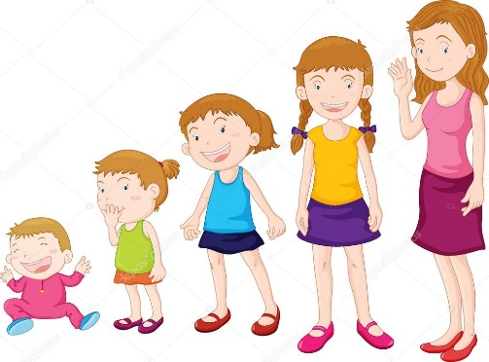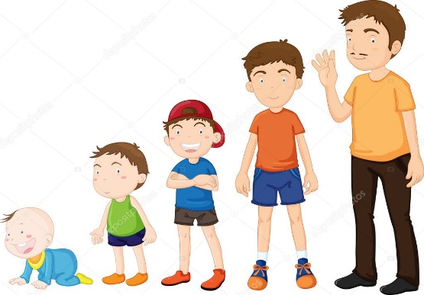

Create a timeline to show/ describe what you were like in different stages of your development.
You could draw it or use photographs. Label it and describe how you have changed.
What could/ couldn’t you do at those different stage?
How did you change? What happened to your body as you changed? How did you appearance change?

