How to establish good bedtime routines
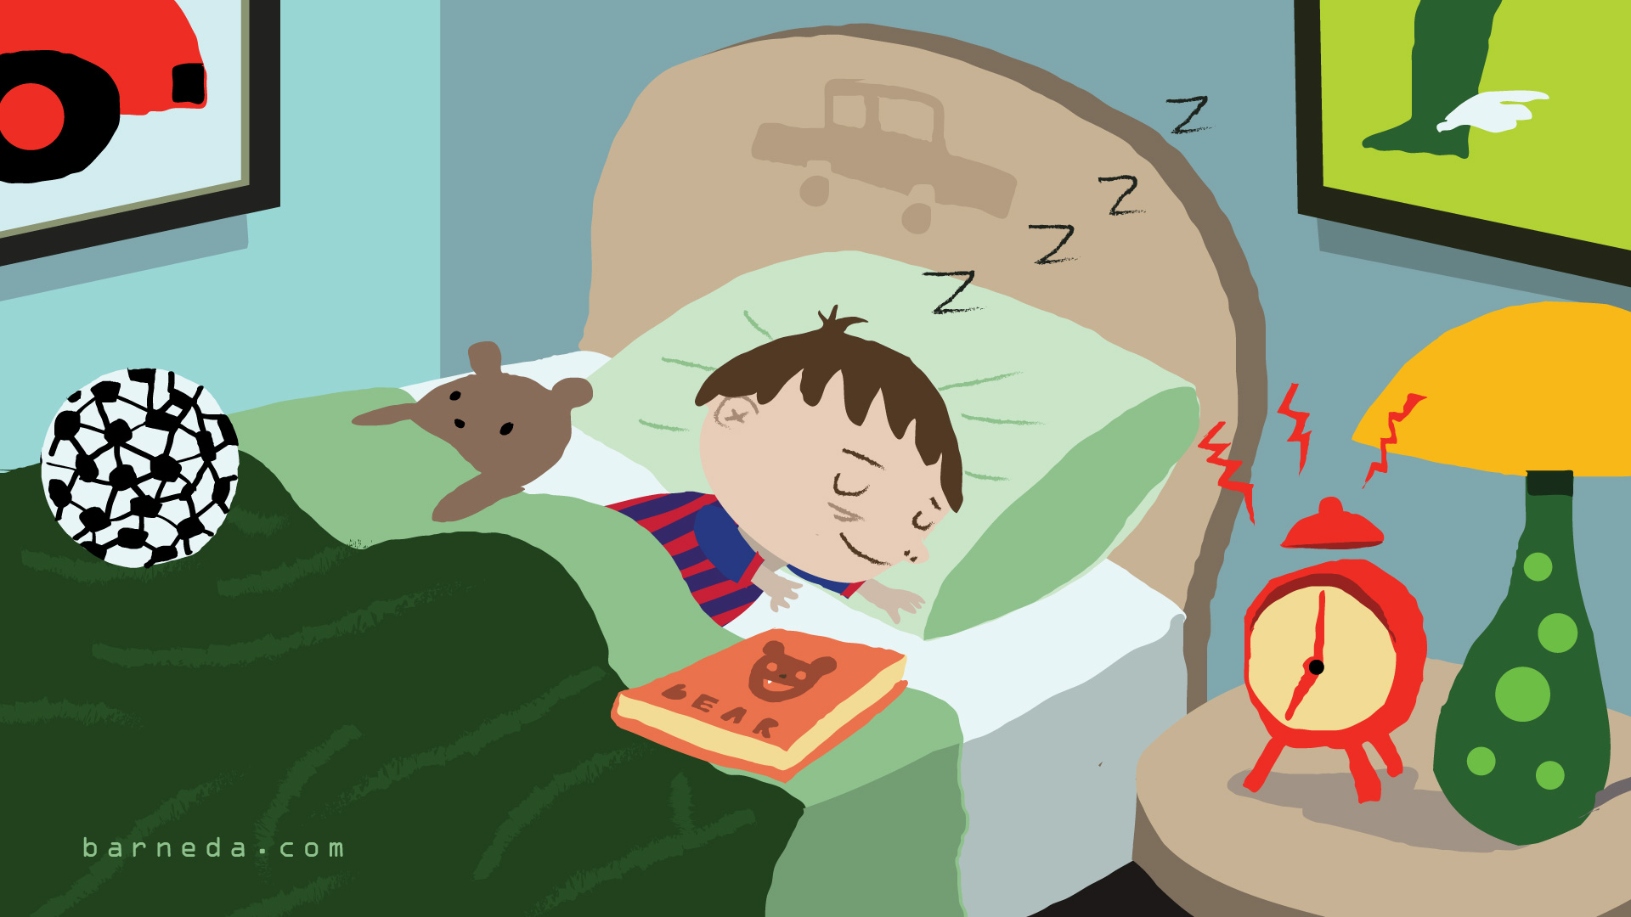
Establishing a good bedtime routine is vital for helping children to feel more secure and comfortable about what they can expect at the end of every day. Routines will change as the child gets older, but it’s important that the child learns basic routines for having a bath/ shower, putting on pyjamas, brushing their teeth and settling themselves to sleep. Allowing some 1:1 time with your child within that routine is also important and gives them comfort as well as helping to build relationships.
In today’s society, it’s easy to allow children to play on tablets/ ipads/ phones before bedtime, but research has indicated that this could lead to their minds being too active to switch off and allow them to rest properly. Watching action packed TV also makes peaceful transition to sleep especially difficult.
The following points help to establish that good bedtime routine:
- Set a specific time for bedtime and stick to it. Some children will complain about this at first, but it’s important to be consistent and to stick to this. Once you give in and change the time, it will be difficult to reinforce it again.
- Give a time warning before time for bed so that your child knows that it is coming. They can then have an opportunity to have that last minute drink or snack before bed. A light snack with protein and carbohydrates in (i.e. a piece of cheese and bread) will help them stay asleep through the night.
- Bathtime/ Shower time By having a warm bath and raising body temperature, it makes us all more sleepy. Having a relaxing, warm bath is great for relaxing the body and mind before bedtime.
- Teeth brushing It’s vital for healthy teeth that they are brushed thoroughly at the end of every day, before bedtime. This helps to remove any bits of food and prevents plaque from building up. Food or drink should not be consumed after teeth brushing, without brushing them again. During the night is the longest period that your teeth can stay clean and bacteria free.
- Getting dressed ready for bed Having specific clothes, which are lose and comfortable for bed helps to make that transition between awake time and relaxing bedtime.
- Reading a story/ having time together for cuddles Having quality 1:1 time and cuddles puts your child at rest and gives them comfort and reassurance before bed. Hearing a story also helps them to relax and their brains to switch off.
- Keep the last “goodnight” brief Say goodnight as you are leaving the room and try not to come back if your child calls for you. If you do return, then your child will learn that you will keep coming back and will carry on shouting for you. It may sound harsh, but your child will settle themselves if they realise that you will not keep returning to their room.
