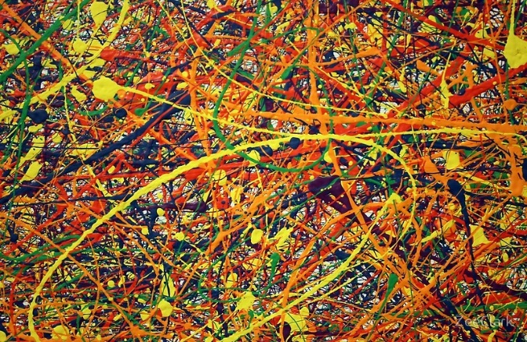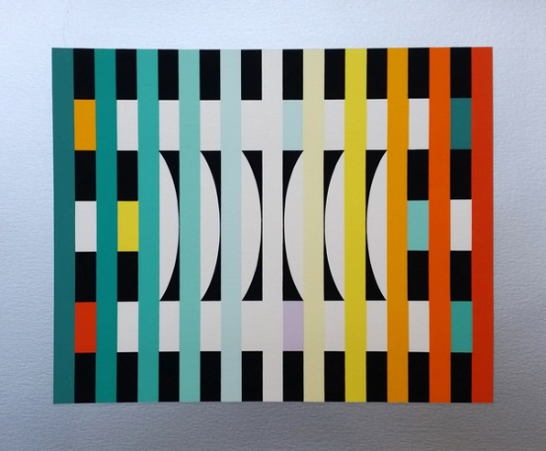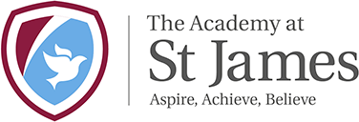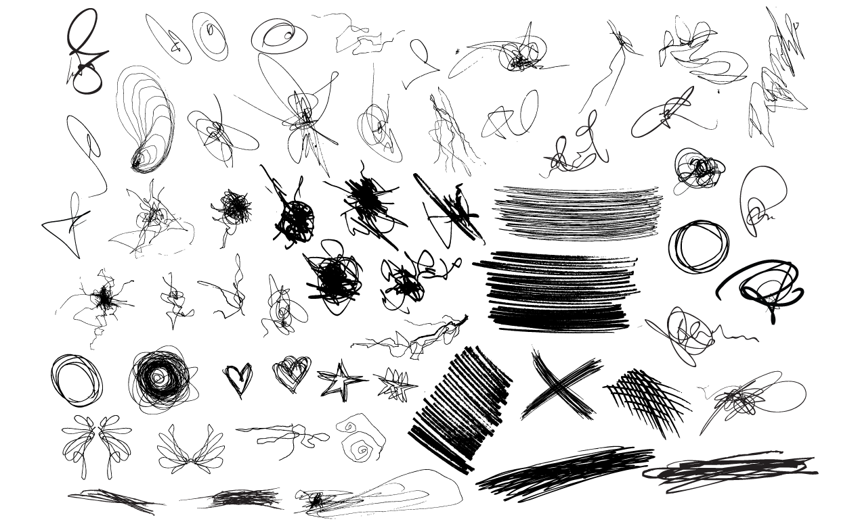

**Art if a fundamental form of human expression.**

***There are two distinct languages. There is the verbal, which separates people…and there is the visual that is understood by everybody.***

**Yakoov Agam**

**Art connects us – to ourselves, to others and to the past.**

***Painting is self-discovery. Every good artist paints what he is.***

**Jackson Pollock**

**Art is vital at St James. Here’s why…**