What were Viking helmets actually like?
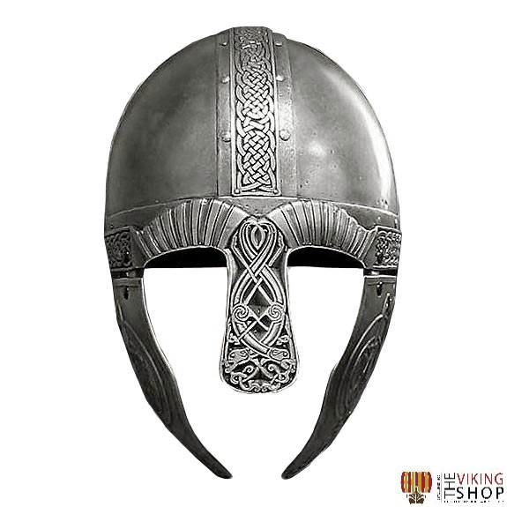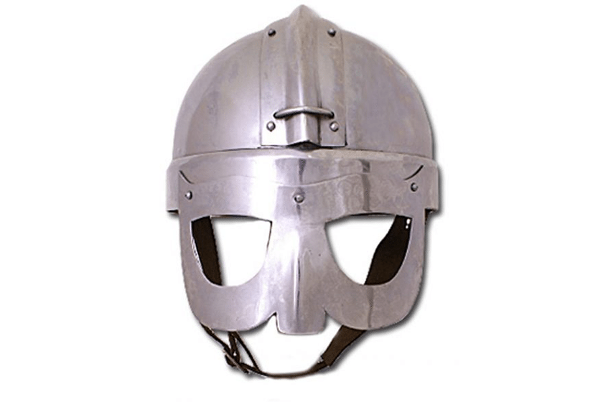
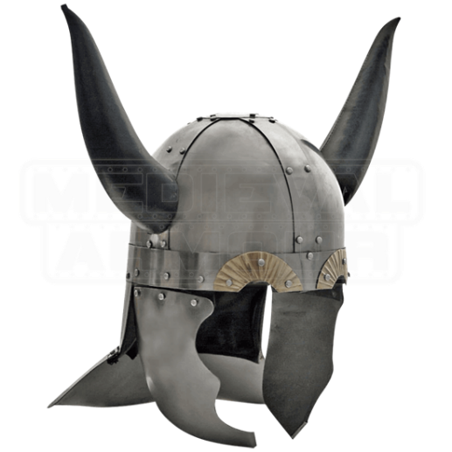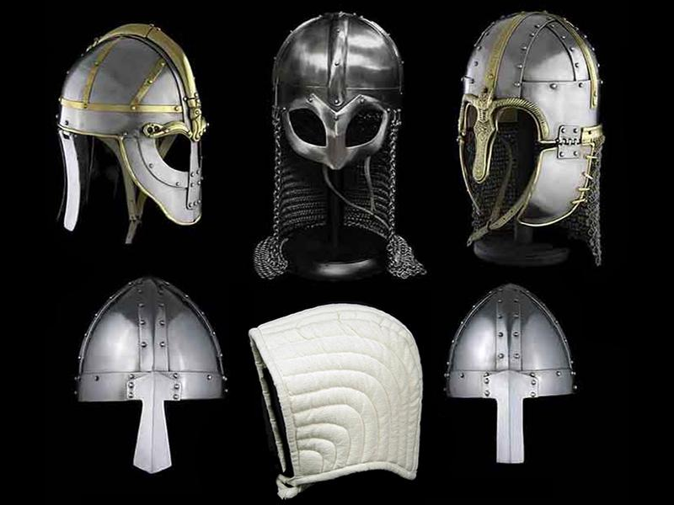
Do some research to find out what they could have been like.
Draw a picture of a Viking helmet.

How to draw a Viking helmet:
https://www.youtube.com/watch?v=a1JlfFK44Lw
https://www.youtube.com/watch?v=pqd_WFLxgRE

