Maths home learning
Your child should be practising:
- Count to 100.
- Read and write numbers to 20.
- Put numbers to 20 in order.
- Recognise and name 2D shapes (circle, square, triangle, rectangle)
- Recognise and name 3D shapes (cube ‘dice’, cuboid ‘cereal box’, cone ‘ice cream cone’ sphere ‘football’, cylinder ‘food tin’.)
- Add and take away numbers to 20

Useful links:
https://www.topmarks.co.uk/maths-games/3-5-years/counting
https://www.oxfordowl.co.uk/for-home/kids-activities/fun-maths-games-and-activities/
http://www.maths-games.org/

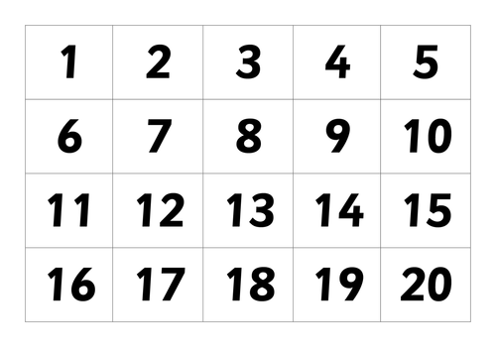

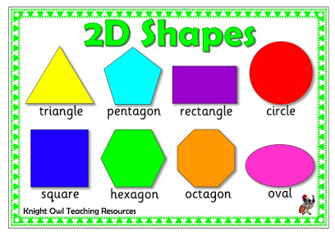

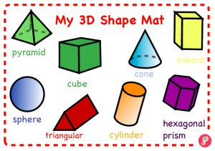

3 + 2 =
6 + 2 =
5 + 4 =
7 + 3 =
5 – 1 =
8 – 3 =
10 – 5 =
9 – 7 =
13 + 2 =
11 + 5 =
16 + 4 =
10 + 9 =
12 – 2 =
14 – 5 =
17 – 7 =
20 – 11 =

