Time Travelling with a Hamster
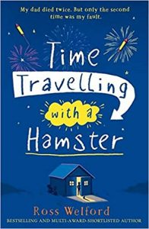
p. 27 – 31

- What does Albert really think of school? How can you tell?
- “My hands give an involuntary tremble…” What does that show us about Albert’s feelings?
- “He crouches down so that his face is level with mine, getting really close, grinning insincerely like one of those crocodiles on nature documentaries.” What does insincerely mean?
- What have you learnt about Albert and his relationship with people at school?

