Monday
Morning Maths
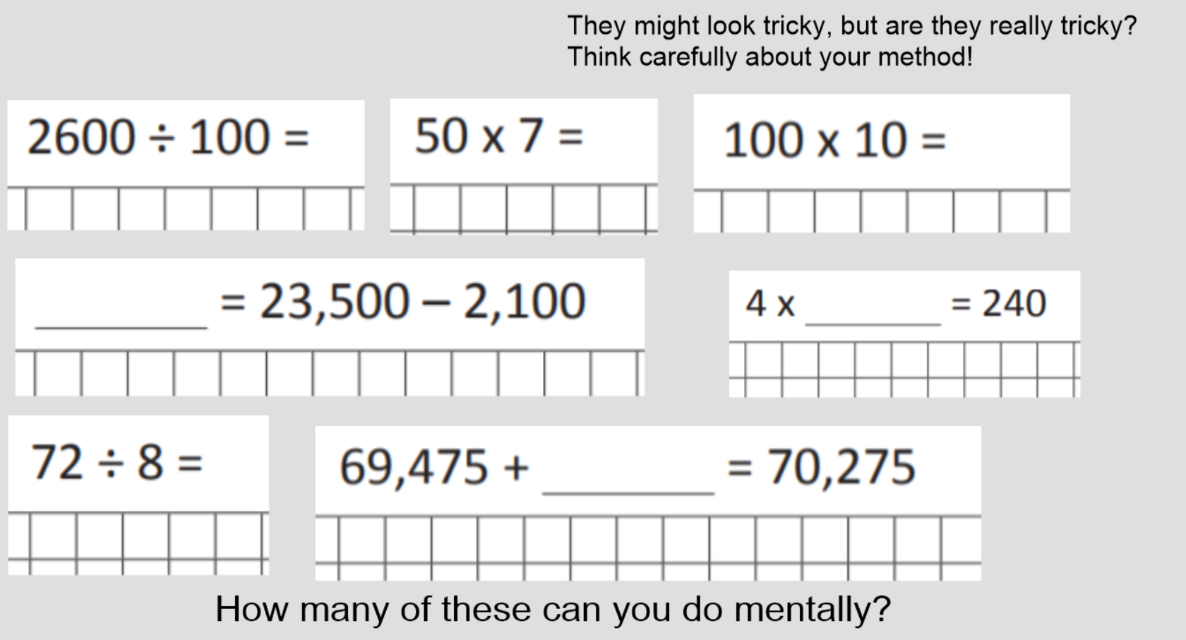
Rounding
Example
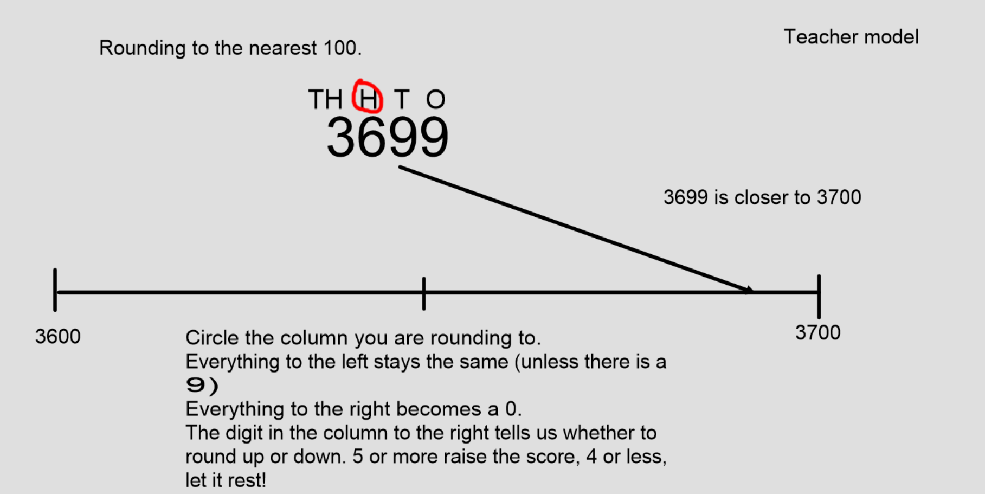

Activity

Round these numbers to the nearest hundred.
- 6,789
- 4,216
- 4,082
- 23,708
- 34,002
- 2649
- 7696
- 2568
- 1020
- 1070
Round these numbers to the nearest 1000.
- 4678
- 8500
- 3208
- 9987
Challenge
