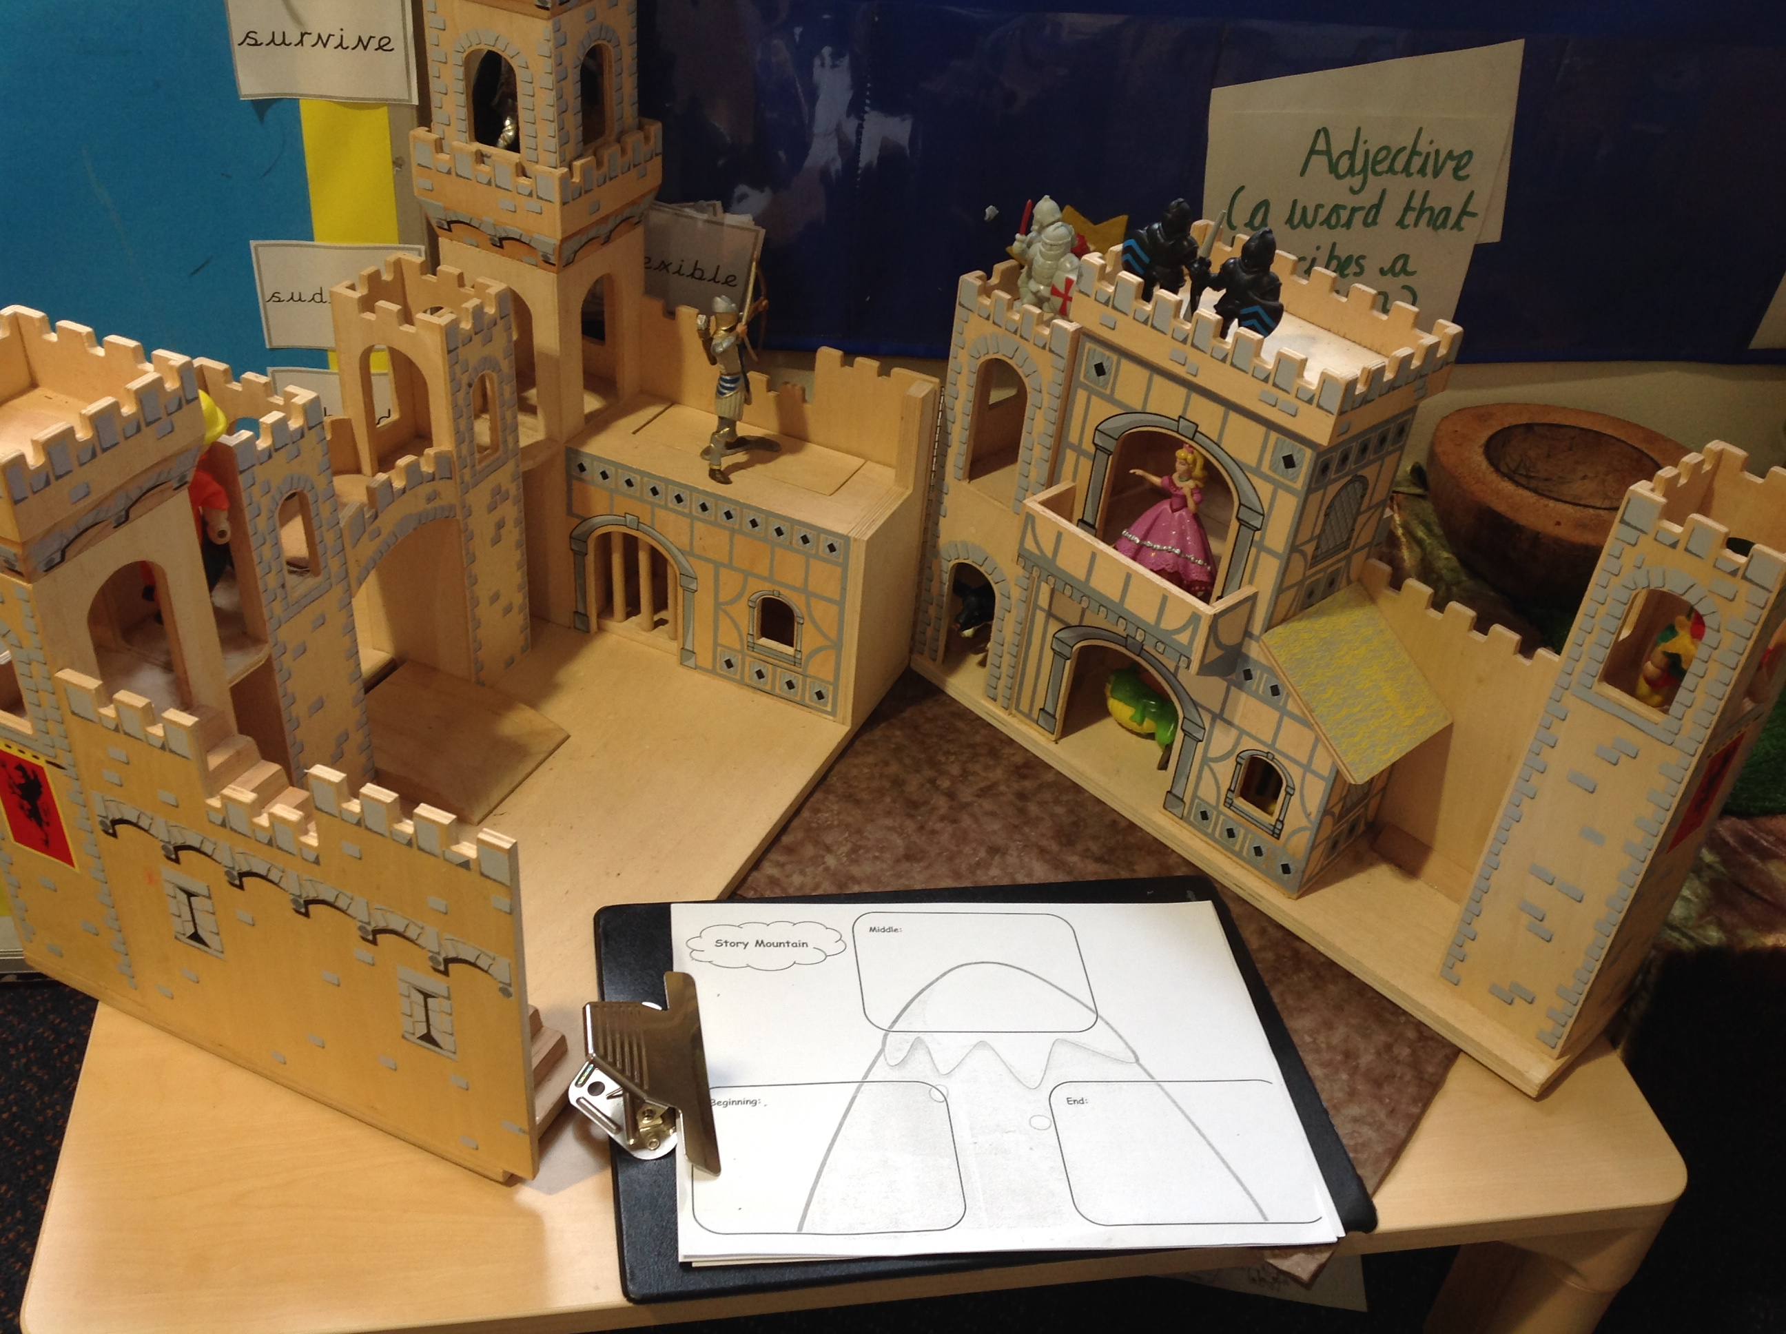
Can you re tell a story to someone at home, maybe you can use props to help you. Remember to use our words of the week in your story.
Find a comfy space at home and enjoy a story together, can you change the story in some way, maybe the characters or the setting or even what happens.

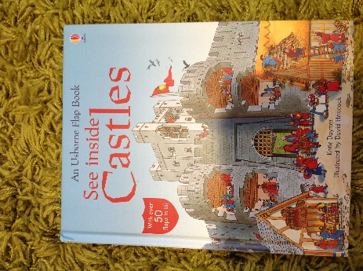
Can you write a fact file about all the information you know about castles? Can you find some information about kings and queens that live in castles and add this to you fact file

Can you design and make a castle. Think about what you have at home you could build with. Eg the tins in the kitchen cupboards, lego, books etc. Make sure you label your design, like we do in school.

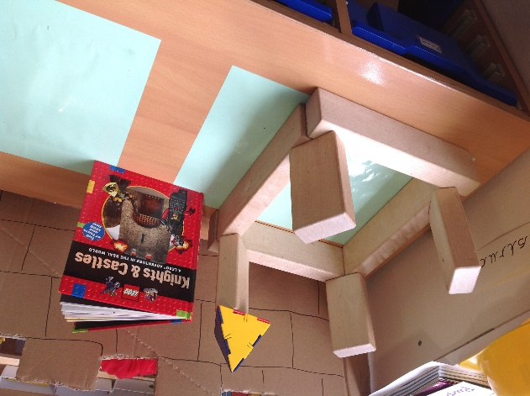

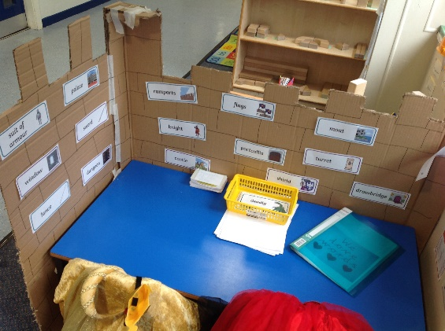
Write a story about a castle. Think about the beginning, the middle and the end. Can you use the correct punctuation and include adjectives and a conjunctions in your writing. What will happen, what characters will you have, think about the setting and any props you might need.
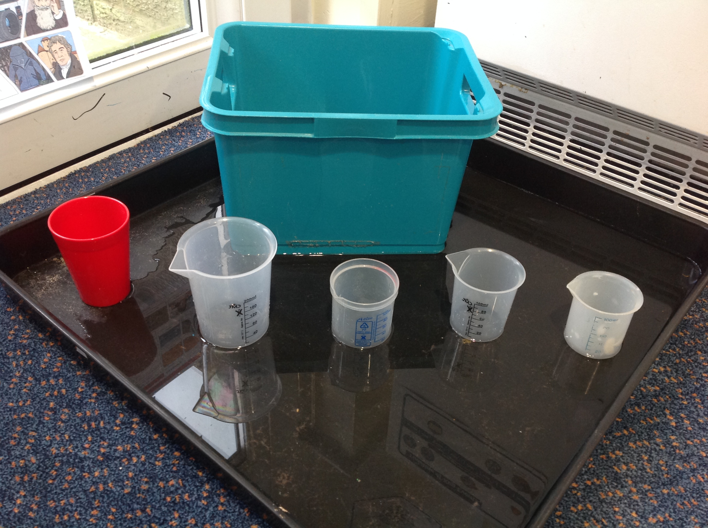
Play with water. How many different containers can you find at home? How much water can each container hold, how will you measure this?
Use language such as full, half full, empty, nearly full, nearly empty.

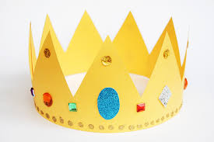
Get creative and make a crown fit for a king or queen.
Make sure you measure you head first before you start decorating it.

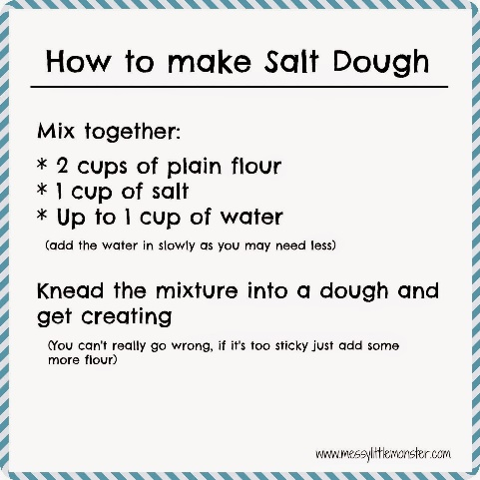
Make some salt dough. Follow the recipe. Then make a shield, fit for a knight. When it is dry, you can paint it,
Other suggestions.
Baking. Can you make some buns or jam tarts? Follow the instructions and weigh out the ingredients carefully using weighing scales.
Drawing. What can you see out of your window? Draw what you see.
Can you draw a portrait of a family member, look carefully at their features?
Junk Modelling. Can you make a castle or a house?
Music. What can you find that makes a sound? Can you make a tune with the things you have? Sing some songs and make up funky dance moves.
Geography. Draw a map of the area where you live and label it. Search on google maps or find an atlas if you’re not sure.
History. Write some interesting facts about any Kings and Queens of England. Can you find any funny facts?
Play a game. Simon says, a memory game (Kim’s game is good) Eye spy, Hide and seek. A board game
How to play Kim’s game?
Playing Kim´s game is a good way of developing your child´s memory skills and concentration – both skills useful for all learning.
Put 10 things from around the house on a tray - it could be things like a pencil, an orange, some cotton wool, a toy etc. Ask your child to look carefully at them for about thirty seconds. Then take the tray away and ask them to call out what they remember.
Another way of playing the game is to cover the things, take one thing away and ask the child to spot what is missing. You can put more things on the tray as they get better.
RE. What do you know about Easter? Can you make a card, draw or paint a picture for a friend or relative?
Fine motor Skills. How many buttons can you fasten in 1 minute?

