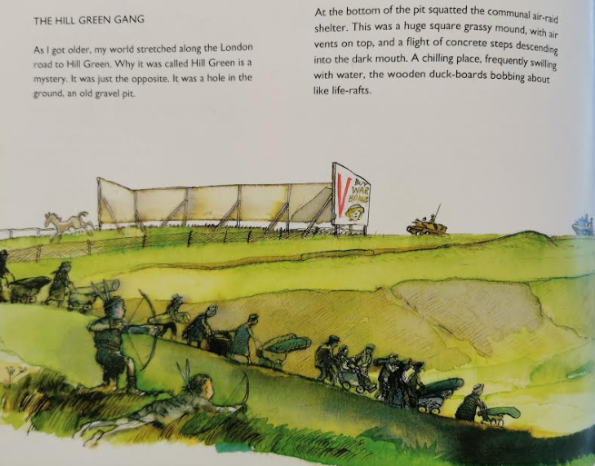
Questions about this page
- Why was he surprised by the name of the Hill Green?

- Which verb tells the reader that the shelter was low to the ground?

- Find and copy the verb which is a synonym for ‘going down’.

- The author describes the Hill Green as ‘chilling’, which means it was frightening. Why do you think the Hill Green might’ve been chilling?

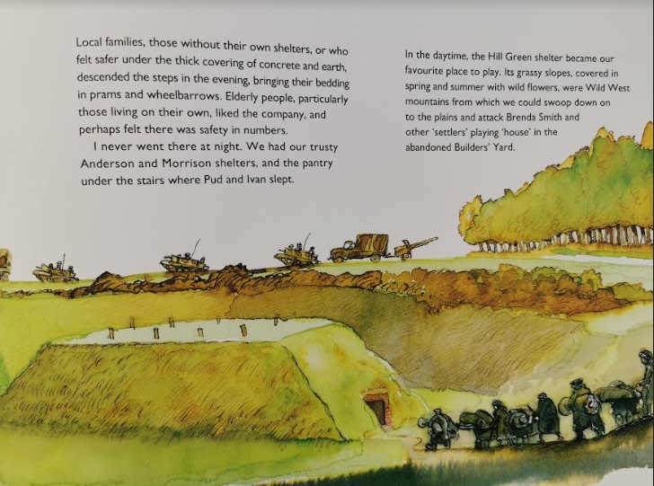

Questions about this page
- What did sheltering families use to transport their bedding?

- Write two reasons why older people liked using this shelter.

- Did he use the shelter at night? If so/not, explain why.

- The Hill Green shelter was a chilling place, that he did not like.
Do you agree with statement? Yes No Maybe
Explain your answer with reference to the text.

Challenge – using the description on pages 46 and 47, draw or build your own version of the Hill Green and the Hill Green shelter.

Remember to share your work with me using Class Dojo, Google Classroom or emailing me directly. Contact me, if you have any problems with this.

