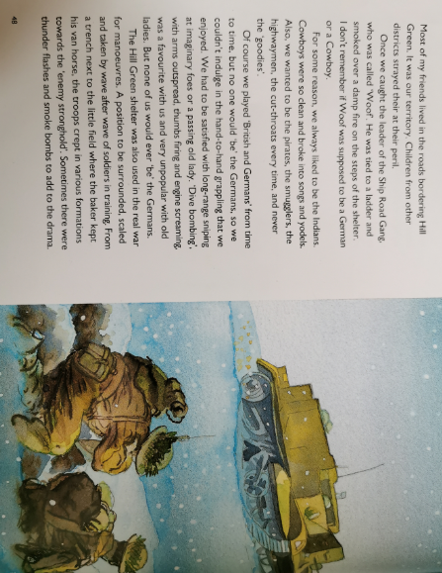

Create a comic strip (example below) showing the Hill Green Gang, using pictures, speech bubbles and thought bubbles. For example, think about what the old ladies might have thought or said to the children.
Who did they see? What did they do? Who did they act like?
