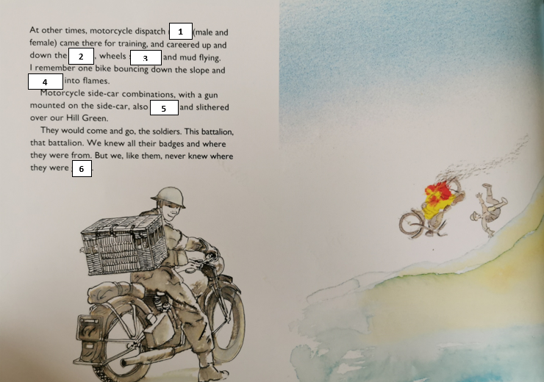
Read the sentences to match the words to the numbers.
Check to make sure the words you choose make sense in the context of the sentence.
roared bursting spinning riders going slopes

1. __________________ 4. __________________
2. __________________ 5. __________________
3. __________________ 6. __________________

- True or False – the riders were all men. Prove your answer!
- What did the side-cars have attached to them?
- Find and copy two things that they knew about the battalions.
- ‘But we, like them, never knew where they were going.’
Explain what you think this means. Why did they not know where they were going? How do you think it would’ve felt to be part of a battalion?
Glossary
battalion (noun) – a military unit of soldiers
careered (verb) – past tense of to career – to move quickly, in an uncontrolled way.

