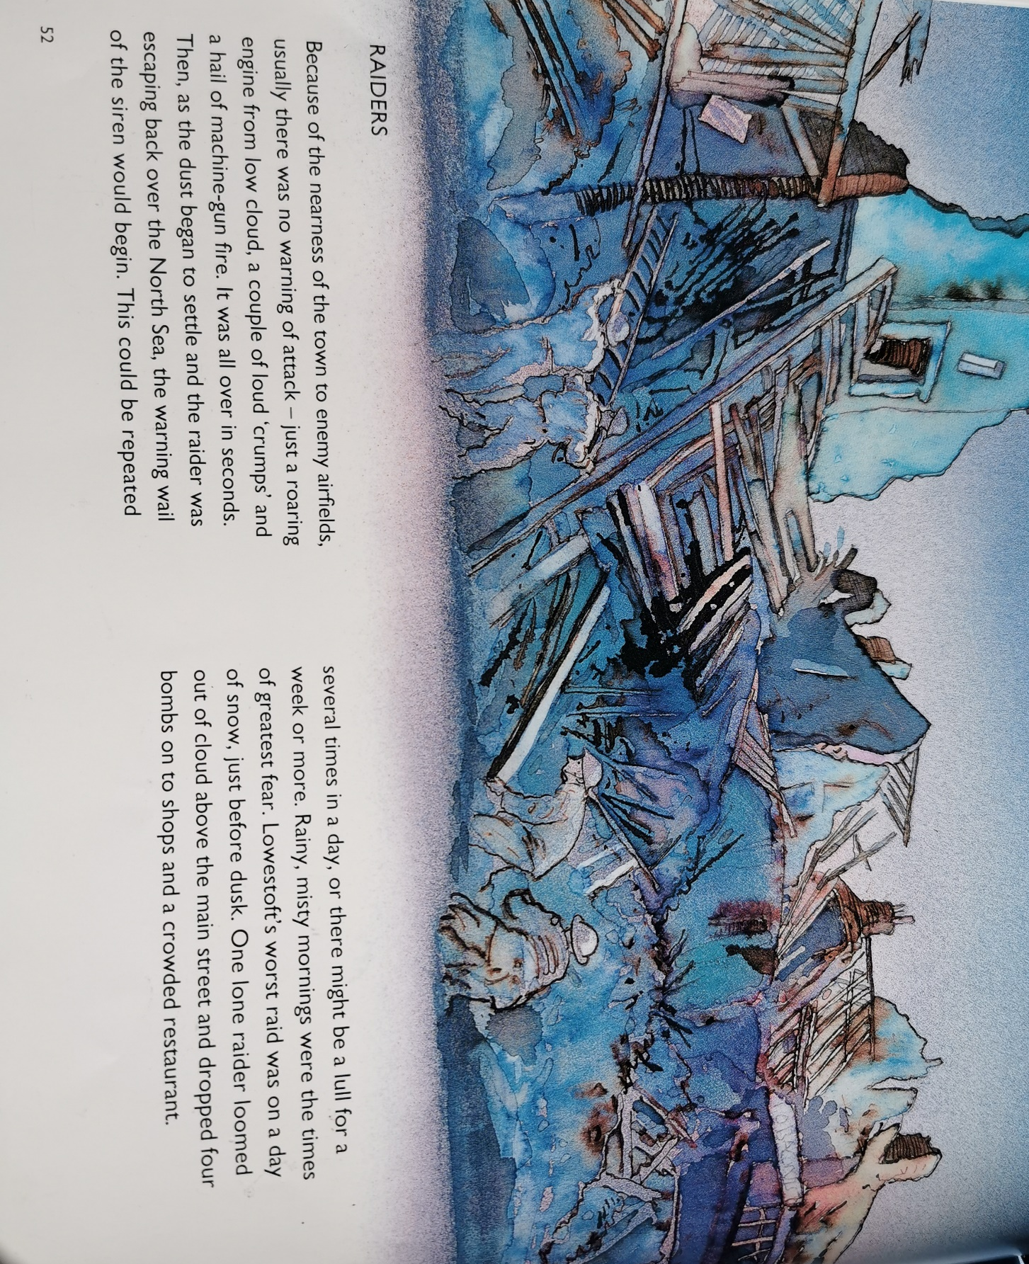

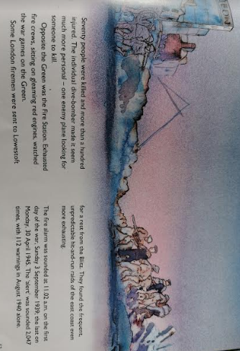

Questions about these pages
- Why was there no warning of attack?

- When would the warning wail or the siren begin?

- When were the times of greatest fear?

- What did the London firemen find more exhausting?

- How many times did the fire alarm in Lowestoft go off during the war?

Now, create a newspaper article for the worst day of bombing that Lowestoft had during the war. Remember to use information from the text, and include features of a newspaper report:
- headline - sum up the news story in a snappy opening sentence
- past tense - 3rd person (they, it, people not I, we, us) – unless using speech
- paragraphs

Use the example provided as a guide, but feel free to do it on a computer or hand-written.

