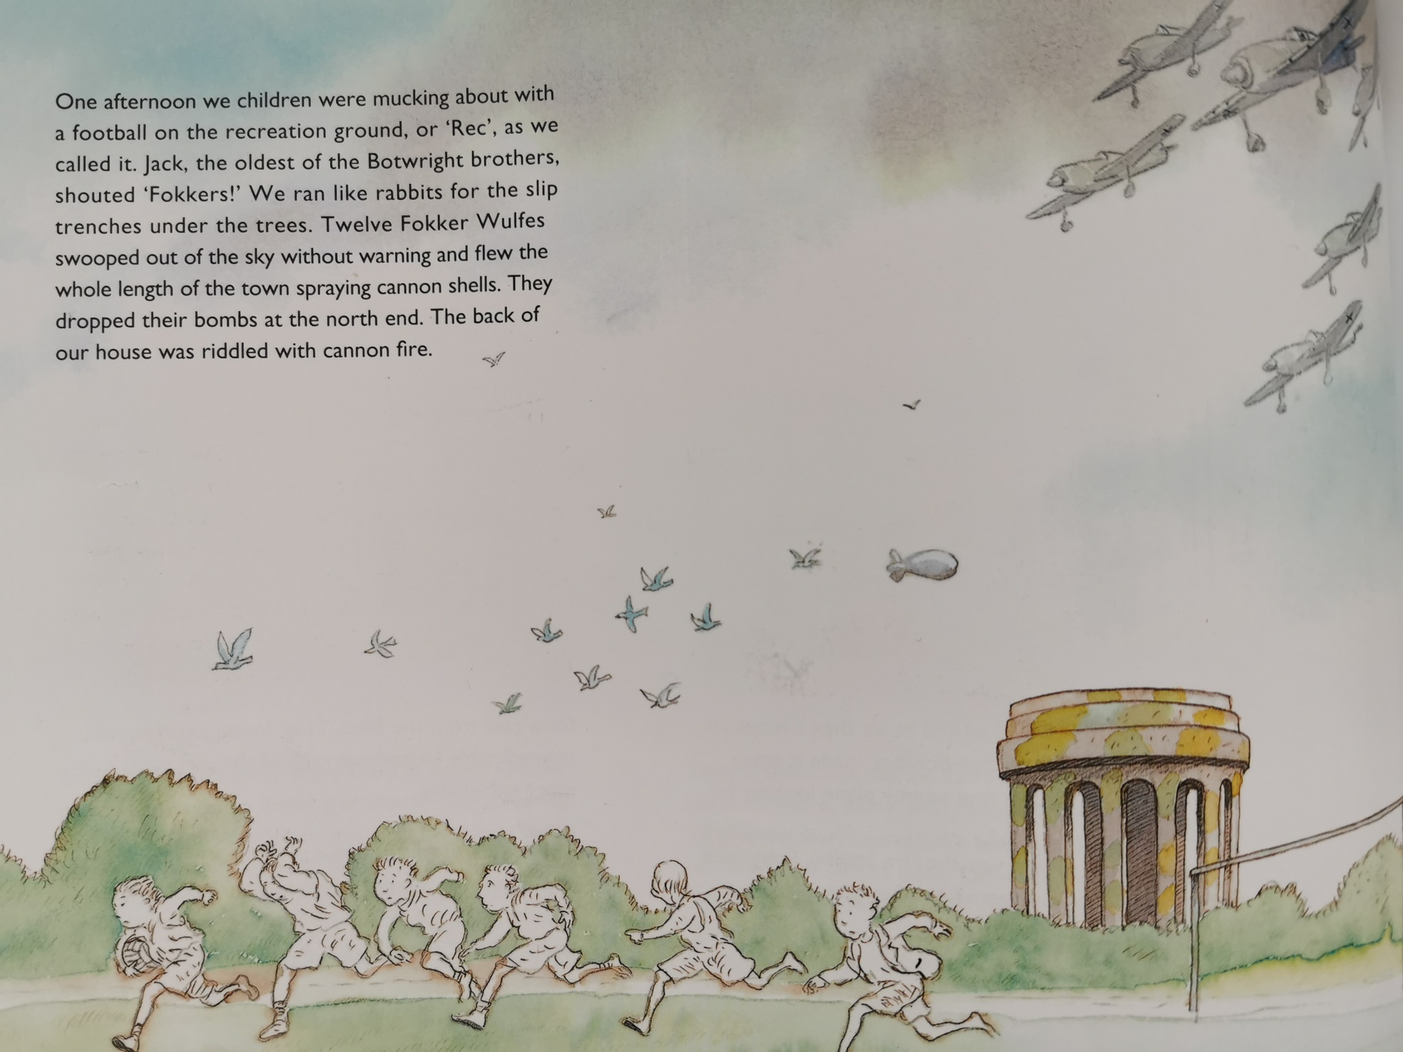

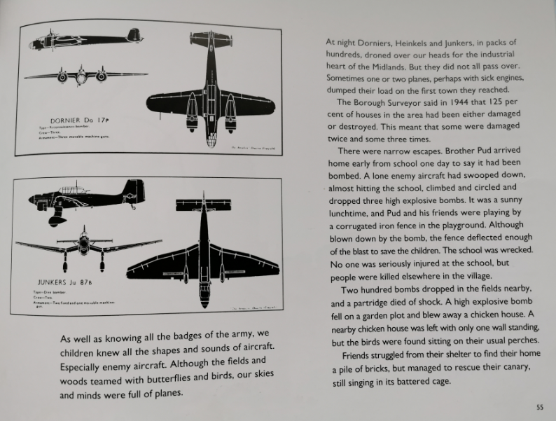
- Which of the following is the odd one out? Explain your answer.
Rec Dornier Heinkel Junker Fokker Wulfe

- Find and copy the phrase on page 54 which suggests the children didn’t know the bomber planes were coming.

- ‘We ran like rabbits for the slip trenches under the trees’
What does this simile suggest about the children?

- What were the children’s minds full of?

- Match the verbs to the appropriate definition:
spray | make many holes in something
riddled | cause something to change direction
drone | scatter (something) with great force
deflect | make a continuous low humming sound
struggle | continue with difficulty

