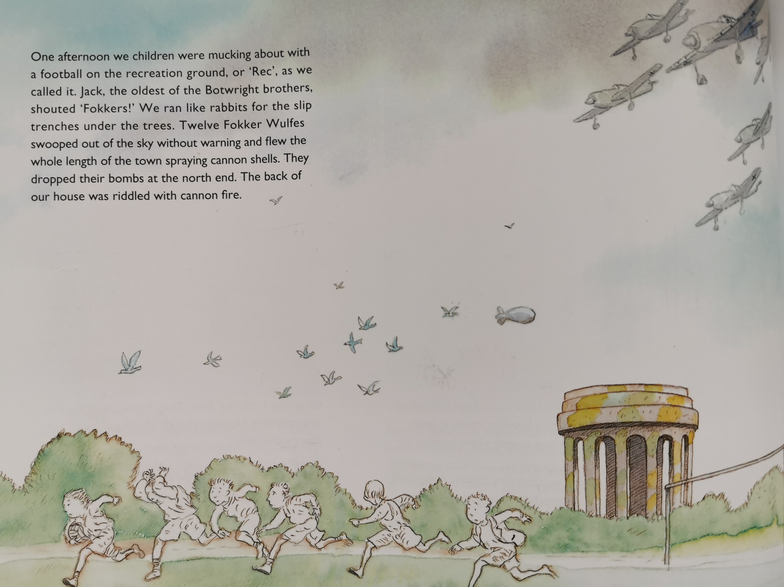

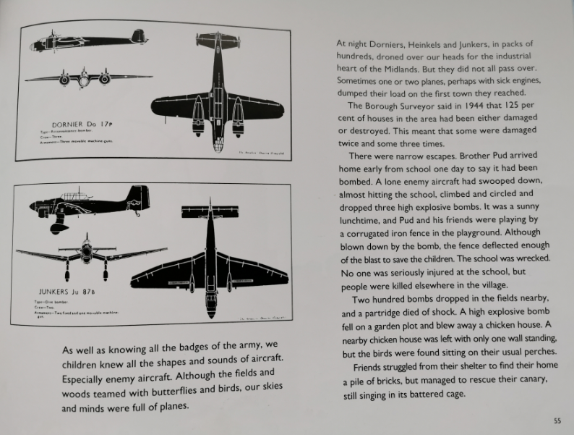

Re-read pages 54-55 of Warboy. Tick to show which statements are true and which are false.
Find evidence in the text to prove your answers.
 | true | false | prove it!
According to the Borough Surveyor, all houses in the area were hit once in 1944.
Two bombs dropped in the fields nearby.
The bomber planes were heading for the Midlands.
One bomber plane destroyed the school.

Now, draw the scene described on page 55, where Pud was out the house and the bomber plane swooped.
Label your illustration, with key words and phrases from the text.

