Reading- Week 2- Day 2
Treasure Island by Robert Louis Stevenson
Chapter II, pages 11-12
Jim Hawkins lives and works at his parents’ inn. A curious old sailor, known as “the captain”, comes to stay. One day, he asks Jim to keep a look out for “a seafaring man with one leg” and let him know the moment he appears.
It was not very long after this that there occurred the first of the mysterious events that rid us at last of the captain, though not, as you will see, of his affairs. It was a bitter cold winter, with long, hard frosts and heavy gales; and it was plain from the first that my poor father was little likely to see the spring. He sank daily, and my mother and I had all the inn upon our hands; and were kept busy enough, without paying regard to our unpleasant guest.
It was one January morning, very early – a pinching, frosty morning – the cove all grey with hoar-frost, the ripple lapping softly on the stones, the sun still low and only touching the hilltops and shining far to seaward. The captain had risen earlier than usual, and set out down the beach, his cutlass swinging under the broad skirts of the old blue coat, his brass telescope under his arm, his hat tilted back upon his head. I remember his breath hanging like smoke in his wake as he strode off, and the last sound I heard of him, as he turned the big rock, was a loud snort of indignation, as though his mind was still running upon Dr. Livesey.
Well, mother was up-stairs with father; and I was laying the breakfast-table against the captain’s return, when the parlour door opened, and a man stepped in on whom I had never set my eyes before. He was a pale, tallowy creature, wanting two fingers of the left hand; and, though he wore a cutlass, he did not look much like a fighter. I had always my eye open for seafaring men, with one leg or two, and I remember this one puzzled me. He was not sailorly, and yet he had a smack of the sea about him too.
I asked him what was for his service, and he said he would take rum; but as I was going out of the room to fetch it he sat down upon a table, and motioned me to draw near. I paused where I was with my napkin in my hand.
“Come here, sonny,” says he. “Come nearer here.”
I took a step nearer.
“Is this here table for my mate, Bill?” he asked, with a kind of leer.
I told him I did not know his mate Bill; and this was for a person who stayed in our house, whom we called the captain.
“Well,” said he, “my mate Bill would be called the captain, as like as not. He has a cut on one cheek, and a mighty pleasant way with him, particularly in drink, has my mate, Bill. We’ll put it, for argument like, that your captain has a cut on one cheek – and we’ll put it, if you like, that that cheek’s the right one. Ah, well! I told you. Now, is my mate Bill in this here house?”

Set A Questions
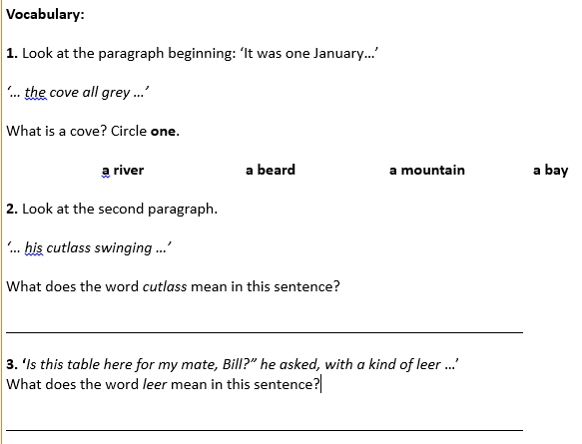
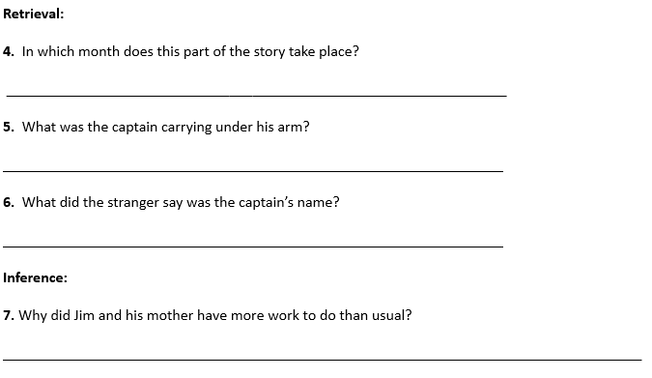
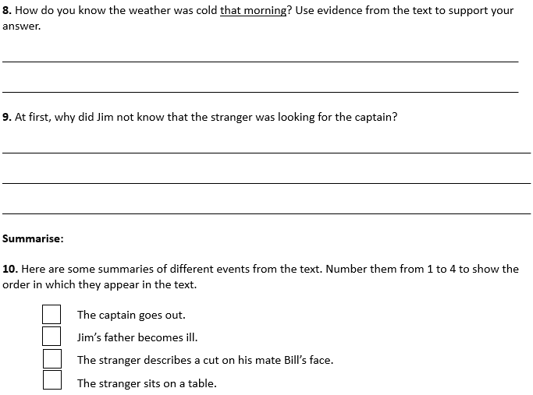
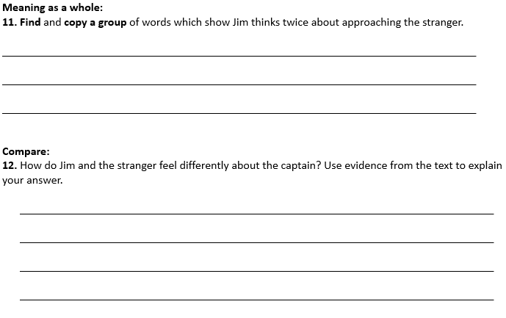

Set B Questions
