Reading- Week 2- Day 3
The Jungle Book
Shere Khan the tiger has attacked a woodcutter’s camp, but their young child has escaped him and walked into the cave of a family of wolves. The Tiger has tracked the child to the cave and wants his prey to be handed over to him.
Shere Khan had jumped at a woodcutter’s campfire, as Father Wolf had said, and was furious from the pain of his burned feet. But Father Wolf knew that the mouth of the cave was too narrow for a tiger to come in by. Even where he was, Shere Khan’s shoulders and forepaws were cramped for want of room, as a man’s would be if he tried to fight in a barrel.
“The Wolves are free people,” said Father Wolf. “They take orders from the Head of the Pack, and not from any striped cattle-killer. The man’s cub is ours – to kill if we choose.”
“Ye choose and ye do not choose! What talk is this of choosing? By the bull that I killed, am I to stand nosing into your dog’s den for my fair dues? It is I, Shere Khan, who speak.”
The tiger’s roar filled the cave with thunder. Mother Wolf shook herself clear of the cubs and sprang forward, her eyes, like two green moons in the darkness, facing the blazing eyes of Shere Khan.
“And it is I, Raksha [The Demon], who answer. The man’s cub is mine, Lungri – mine to me! He shall not be killed. He shall live to run with the Pack and to hunt with the Pack; and in the end, look you, hunter of little naked cub – frog-eater – fish killer – he shall hunt thee! Now get hence, or by the Sambhur that I killed (I eat no starved cattle), back thou goest to thy mother, burnt beast of the Jungle, lamer than ever thou earnest into the world! Go!”
Father Wolf looked on amazed. He had almost forgotten the days when he won Mother Wolf in a fair fight from five other wolves, when she ran in the Pack and was not called The Demon for compliment’s sake. Shere Khan might have faced Father Wolf, but he could not stand up against Mother Wolf, for he knew that where he was she had all the advantage of the ground, and would fight to the death. So he backed out of the cave-mouth growling, and when he was clear he shouted –
“Each dog barks in his own yard! We will see what the Pack will say to this fostering of man-cubs. The cub is mine, and to my teeth he will come in the end, O bush-tailed thieves!”
Mother Wolf threw herself down panting among the cubs, and Father Wolf said to her gravely –
“Shere Khan speaks this much truth. The cub must be shown to the Pack. Wilt thou still keep him, Mother?”
“Keep him!” she gasped. “He came naked, by night, alone and very hungry; yet he was not afraid! Look, he has pushed one of my babes to one side already. And that lame butcher would have killed him and would have run off to the Waingunga while the villages here hunted through all our lairs in revenge. Keep him? Assuredly I will keep him. Lie still, little frog. O thou Mowgli – for Mowgli the Frog I will call thee – the time will come when thou wilt hunt Shere Khan as he has hunted thee.”

Set A Questions
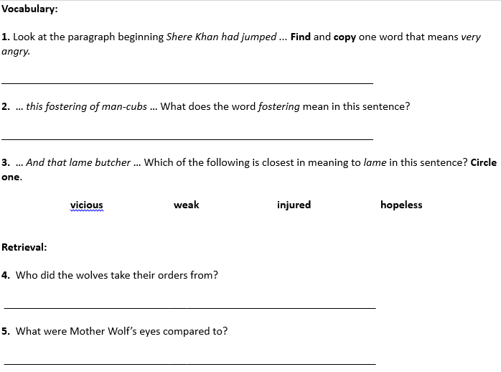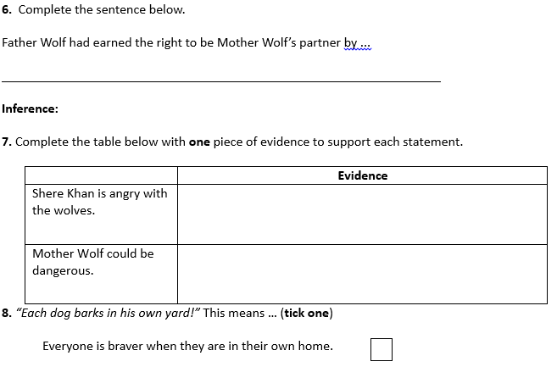
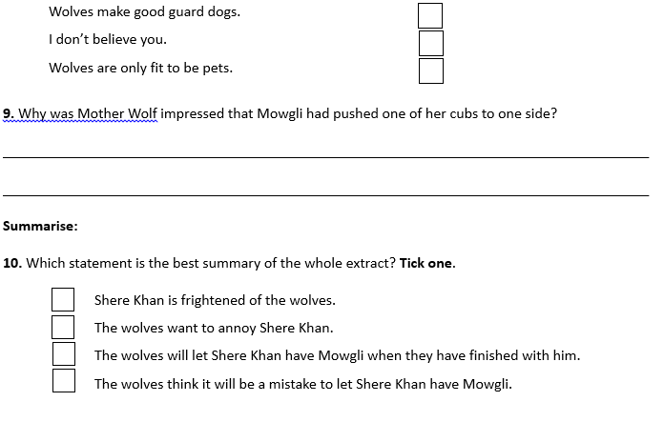
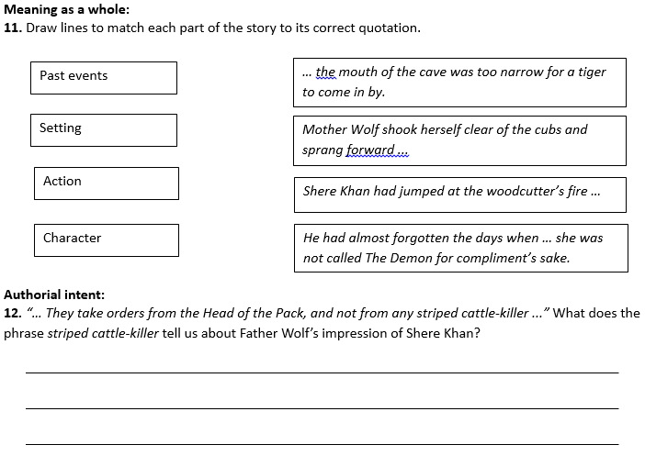

Set B Questions
