Reading- Week 2- Day 4
Jabberwocky by Lewis Carroll
‘Beware the Jabberwock, my son!
The jaws that bite, the claws that catch!
Beware the Jubjub bird, and shun
The frumious Bandersnatch!’

He took his vorpal sword in hand:
Long time the manxome foe he sought—
So rested he by the Tumtum tree,
And stood awhile in thought.

And, as in uffish thought he stood,
The Jabberwock, with eyes of flame,
Came whiffling through the tulgey wood,
And burbled as it came!

One, two! One, two! And through and through
The vorpal blade went snicker-snack!
He left it dead, and with its head
He went galumphing back.

Set A Questions
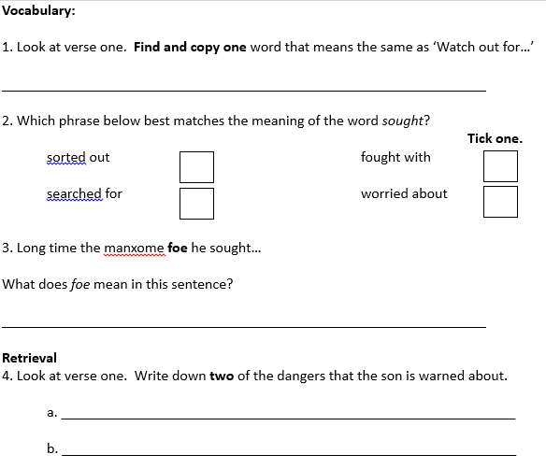
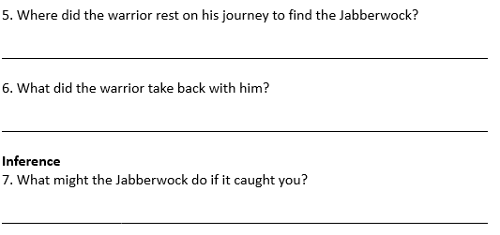
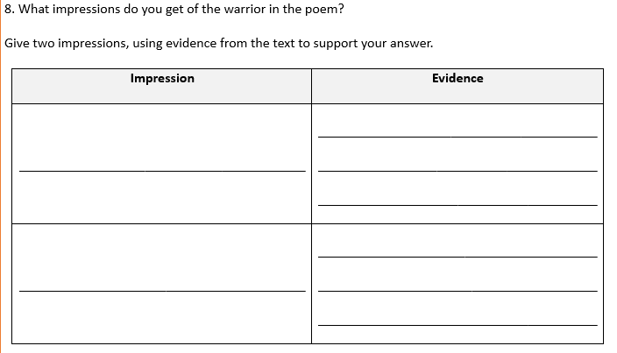
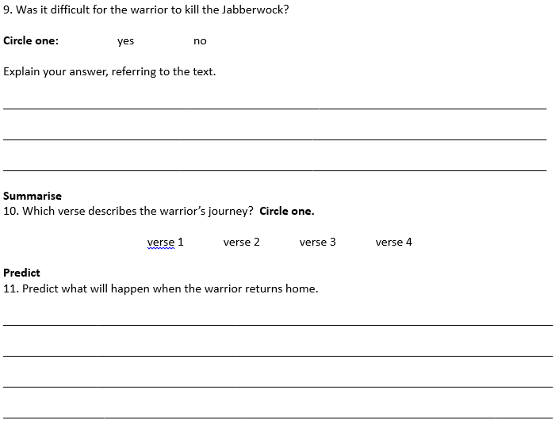
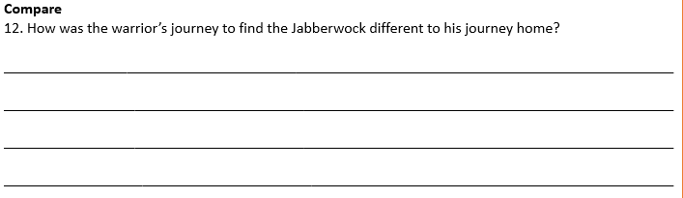
Set B Questions
