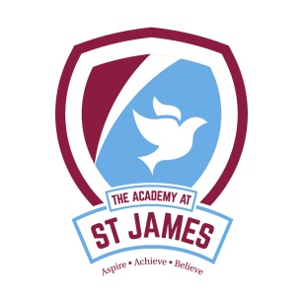
Dear Parent/Carer

Re: School parking

West Yorkshire Police and Bradford Council are committed to improving driving and parking standards around our schools ensuring the safety of all.

We receive a high number of complaints of inconsiderate and dangerous parking around schools. Examples include parking on pavements, causing obstructions, blocking driveways, parking on double yellow lines, parking where there are double white lines in the centre of the road, and allowing children to exit vehicles whilst stopped on School Keep Clear ‘zig-zags’ or in queuing traffic. There have even been instances of abusive and threatening behaviour by parents and carers. This behaviour and standard of driving and parking are wholly unacceptable and most importantly put your children’s safety at risk.

We request that you adhere to the following;

- Do not park or drop off on the ‘Keep Clear’ school zig zags markings
- Do not park on single and double yellow lines or where there are double white lines in the centre of the road
- Adhere to local parking restrictions
- Do not block pavements, driveways or pedestrian access
- Turn off the vehicle engine when parked – this creates an unpleasant and unhealthy environment for pedestrians and releases harmful emissions
- Behave in a manner that is respectful towards others – including pedestrians and local residents.

Drivers found committing the above offences place themselves at risk of being prosecuted/issued tickets by both Council Wardens and Police.

If it is necessary to use a vehicle to drop your child off then we request that you allow extra time in order to park and drop off safely and legally.

We request your cooperation in this matter in order to improve standards and ultimately keep school children safe.

As a school we are trying hard make sure that the pupils are safe crossing the road and need your support in doing this

Yours sincerely

Christopher Tolson Becky Albentosa and Andrew Smart

Headteacher Safeguarding Team

