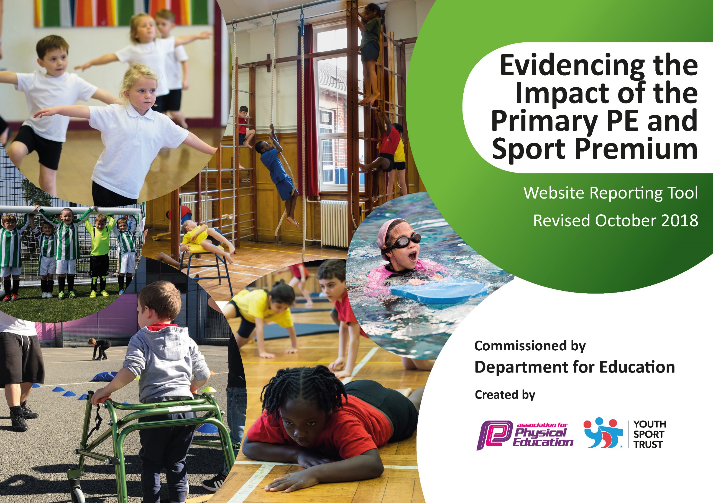
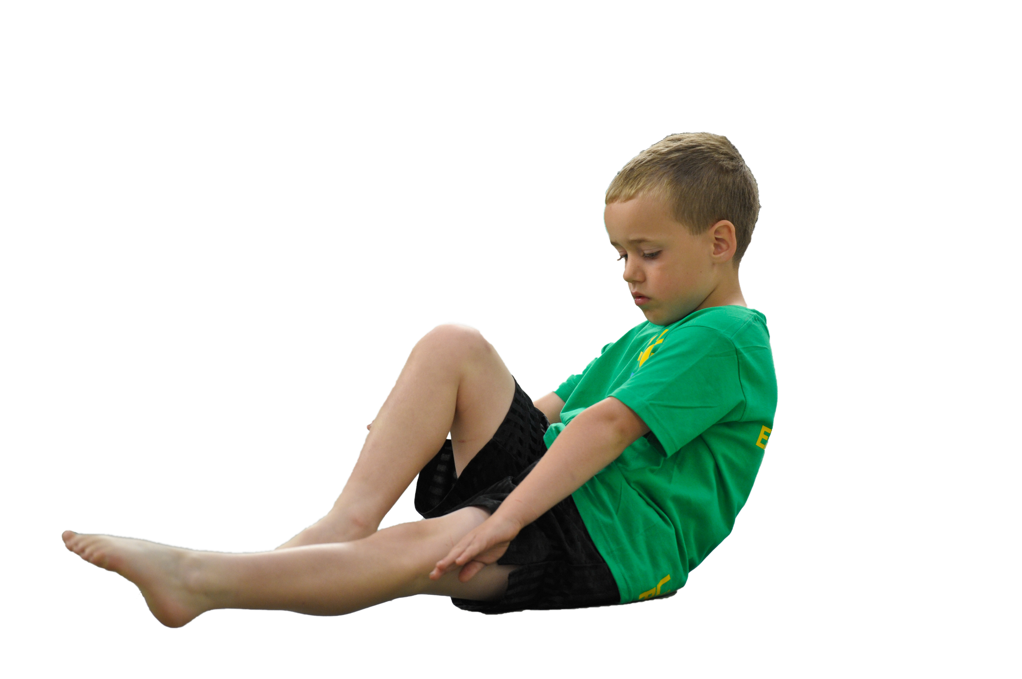
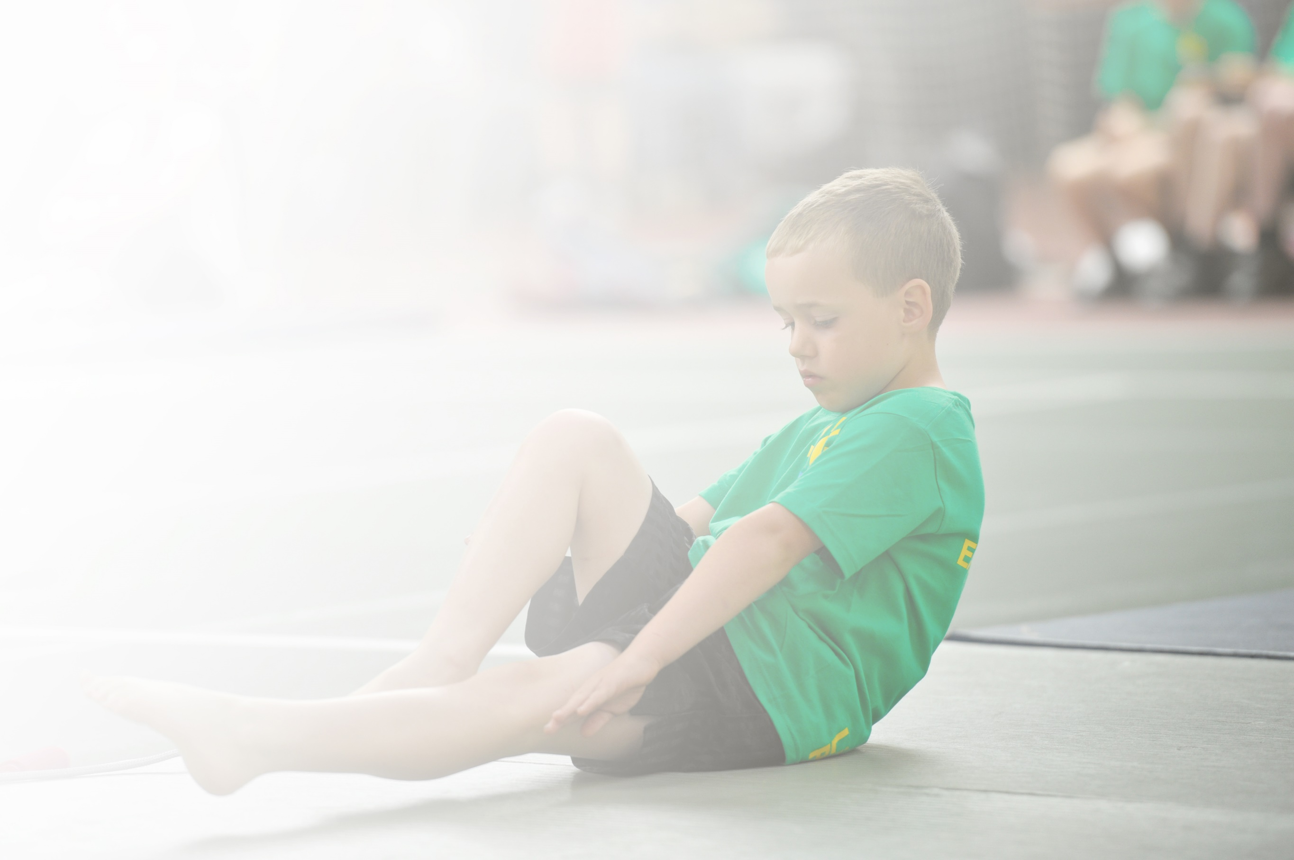
Schools must use the funding to make additional and sustainable improvements to the quality of Physical Education, Sport and Physical Activity (PESPA) they offer. This means that you should use the Primary PE and Sport Premium to:

- Develop or add to the PESPA activities that your school already offer
- Build capacity and capability within the school to ensure that improvements made now will benefit pupils joining the school in future years

Please visit gov.uk for the revised DfE guidance including the 5 key indicators across which schools should demonstrate an improvement. This document will help you to review your provision and to report
your spend. DfE encourages schools to use this template as an effective way of meeting the reporting requirements of the Primary PE and Sport Premium.

We recommend you start by reflecting on the impact of current provision and reviewing the previous
spend. Under the Ofsted Schools Inspection Framework, inspectors will assess how effectively leaders use the Primary PE and Sport Premium and measure its impact on outcomes for pupils, and how effectively governors hold them to account for this.

Schools are required to publish details of how they spend this funding as well as on the impact it has on pupils’ PE and sport participation and attainment by the end of the summer term or by 31 July 2019 at the
latest.
We recommend regularly updating the table and publishing it
on your website throughout the year, as evidence of your
ongoing review into how you are using the money to
secure maximum, sustainable impact. To see an
example of how to complete the table please
click HERE.

Support for review and reflection - considering the 5 key indicators from DfE, what development needs are a priority for your setting and your students now and why? Use the space below to reflect on previous spend, identify current need and priorities for the future.

Key achievements to date: | Areas for further improvement and baseline evidence of need:
An improvement in the % of pupils swimming in all areas. This will get even better in 2020 with:  25m 77.27%  Range 81.82%  Self rescue 18.18%  Teachers are delivering P.E to their own class and pupils have been accessing competitions on a more regular basis.  Linked with Sport England with £30,000 worth of funding to support physical activity. | - Develop a more physically active curriculum to support pupils of all abilities  - Support and train staff with a high level of CPD to strengthen understanding and subject knowledge.  - Work with Sport England to look a holistic picture of pupil physical activity and engage parents.  - Support and provide effective CPD for all staff to improve confidence, knowledge and skills.  - Provide support and CPD for the new PE/Forest School leader.  - Create more opportunities for children to be active within their daily  - timetable in and out of class  - Continue to develop Schemes such as Active Phonics and Active Maths  within KS1 PE and clubs e.g TagTiv8  - Enter A, B and C teams in external competitions  - Structured areas for all children to access at break and lunchtimes.  - Increase the range of extracurricular sports clubs to ensure all Key  stages have opportunities to participate in clubs.

Meeting national curriculum requirements for swimming and water safety | Please complete all of the below:
What percentage of your current Year 6 cohort swim competently, confidently and proficiently over a distance of at least 25 metres?  N.B. Even though your children may swim in another year please report on their attainment on leaving  primary school. | 58.3%
What percentage of your current Year 6 cohort use a range of strokes effectively [for example, front crawl, backstroke and breaststroke]? | 60.4%
What percentage of your current Year 6 cohort perform safe self-rescue in different water-based situations? | 10%
Schools can choose to use the Primary PE and Sport Premium to provide additional provision for swimming but this must be for activity over and above the national curriculum requirements. Have you used it in this way? | No

Action Plan and Budget Tracking
Capture your intended annual spend against the 5 key indicators. Clarify the success criteria and evidence of impact that you intend to measure to evaluate for students today and for the future.

Academic Year: 2018/19 | Total fund allocated: £ | Date Updated:
Key indicator 1: The engagement of all pupils in regular physical activity – Chief Medical Officer guidelines recommend that primary school children undertake at least 30 minutes of physical activity a day in school |  |  |  | Percentage of total allocation:
 |  |  |  | 20%
School focus with clarity on intended impact on pupils: | Actions to achieve: | Funding allocated: £3750 | Evidence and impact: | Sustainability and suggested next steps:
To continue to improve the provision and access for EY and KS1 pupils  To ensure pupils are physical active regularly in the school day  To develop the quality of teaching of PE to ensure pupils receive high quality teaching  To develop and improve the quality of resources to support pupils play in all areas of school life | PE lead/Forest School recruitment for January 2019 start to support and deliver effective CPD for staff.  Curriculum lead and PE lead to develop effective curriculum links- link up with Sport England project (JUMP)  Review physical activity  Year 1-5 take part in a research project measuring physical activity  Work with Sport England to develop an action plan to develop physical activity across the school  Purchase specialist equipment to enable children to participate in wider range of activities | N/A  £750 cover  N/A  £3000  (Sport England fixed cost £5k**)
Key indicator 2: The profile of PESSPA being raised across the school as a tool for whole school improvement |  |  |  | Percentage of total allocation:
 |  |  |  | 5%
School focus with clarity on intended impact on pupils: | Actions to achieve: | Funding allocated: £1000 | Evidence and impact: | Sustainability and suggested next steps:
To develop the role of the new PE leader/Forest School leader.  To develop the awareness and progression for EYFS and physical development | - Improve standards of taught Physical Education across the school  - Identify resources to enhance existing provision which contributes to ‘Personal Development, Behaviour and Attitude’ of pupils  - Review the impact of 2018/19 PE Premium, identify achievements and areas for development  - Build on previous years successes, strategically investing in the 2019/20 PE Premium funding  - Work towards receiving regional/national recognition for our investment and commitment to PESSPA  - Provide support to BDAT cluster schools surrounding all aspects of PESSPA  - Use Sport England and links to EYFS to develop a centre for excellence for physical development | £1000  Training CPD YST

Key indicator 3: Increased confidence, knowledge and skills of all staff in teaching PE and sport |  |  |  | Percentage of total allocation:
 |  |  |  | 13%
School focus with clarity on intended  impact on pupils: | Actions to achieve: | Funding  allocated: £2500 | Evidence and impact: | Sustainability and suggested  next steps:
To source and deliver effective CPD for teachers on key skills and warm up activities  To use JUMP support network to provide support to increase confidence, skills and knowledge of all staff in teaching PE and sport | • Provide a variety of opportunities for pupils to enjoy positive early experiences surrounding physical activity at break & lunchtime  • Collaborate with BIB research/JUMP stakeholders to form part of the LDP project to improve health outcomes for children and families  • Carry out an audit of staff skills, confidence and competence  • Access/attend CPD to embed ‘My personal best’ resource provided by YST  • Reduced negative incidents/ improved wellbeing due to high levels of engagement and readiness for learning  - Cross curricular examples of physical activity being used to support learning | £2500
Key indicator 4: Broader experience of a range of sports and activities offered to all pupils |  |  |  | Percentage of total allocation:
 |  |  |  | 63%
School focus with clarity on intended  impact on pupils: | Actions to achieve: | Funding  allocated: £11,850 | Evidence and impact: | Sustainability and suggested  next steps:
To develop an inclusive after school/enrichment offer that meets the needs of all pupils  Additional achievements:  Broaden the range of experiences and opportunities to try out a range of sporting activities  To develop and provide a high quality Forest School programme which is accessible to all pupils | - Develop Sporting/PA opportunities for in curriculum enrichment making links to SMSC/  - Plan and lead initiatives to encourage classes to compete to be the most active class during that week/half term  - Offer a staff wellbeing/activity ‘catch up’ club  - % of pupils meeting the criteria for swimming continues to improve to above 75%  - Phil Lowde to plan and deliver a quality Forest School programme (planned with teachers)  - Work with Living Streets, Daniel Bingham to look at how pupils travel to and from school  - Research existing ‘good practice models’ i.e ‘Fitbit challenge’ Celebrate the most active class in assembly.  - Identify and book providers offering Fencing, Ballroom Dance & EYFS music, movers and shaker | £6,000 –CPD and equipment + training  (Forest School development 1 day a week)  £1000 resources  Swimming  £5,850
Key indicator 5: Increased participation in competitive sport |  |  |  | Percentage of total allocation:
 |  |  |  | 3%
School focus with clarity on intended  impact on pupils: | Actions to achieve: | Funding  allocated: £500 | Evidence and impact: | Sustainability and suggested  next steps:
To work with local networks to create opportunities and organize more competitions for children to take part in.  To work with Sport England to look for opportunities to take part in other strands of sport and competitions | • Attend a variety of competitions organised by the SSP  • Plan and coordinate league fixtures/competitions/festivals with BDAT cluster schools  - Introduce new opportunities for sport/outdoor education.  - Develop orienteering, climbing, low ropes course, cycling and archery  *Costs for this will be supported through Sport England project | £500

