Reading booklet for parents
Helping your child to read

At The Academy at St James, our aim is to support children along their way to becoming lifelong readers. The purpose of this booklet is to provide you with information which will enable you to support your child’s reading at home.

Learning to read takes time. Decoding the text and being able to read the words on the page is only the first step. Children need time to understand what they are reading and to enjoy books. Given the time to learn at their pace, children will develop resilience as readers and develop the lifelong skills they need to make them confident in their reading abilities.
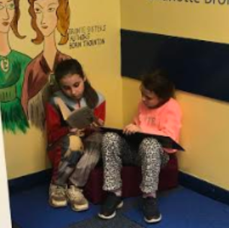
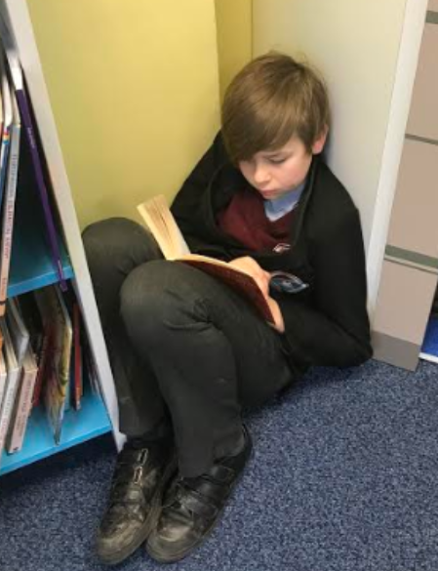

Strategies to try at home:
• Talk about the book with your child before reading – you could introduce any words to them you think they will struggle with.
• Encourage your child to read a section/the whole book again to make sure it makes sense and to improve the expression.
• If they are finding a book difficult, don’t ask your child to sound out every word - focus on words you know that your child can decode.
• Sometimes read with your child (paired reading) or take it in turns to read a page.
• Draw your child’s attention to repeated words – encourage them to read them by sight, instead of sounding out.
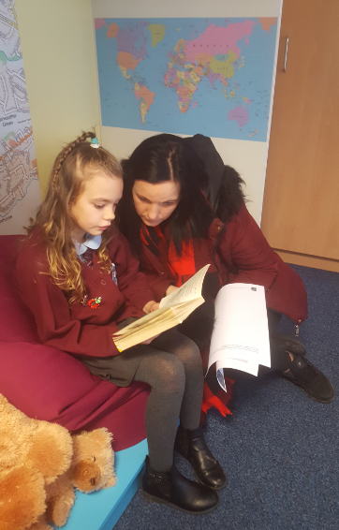
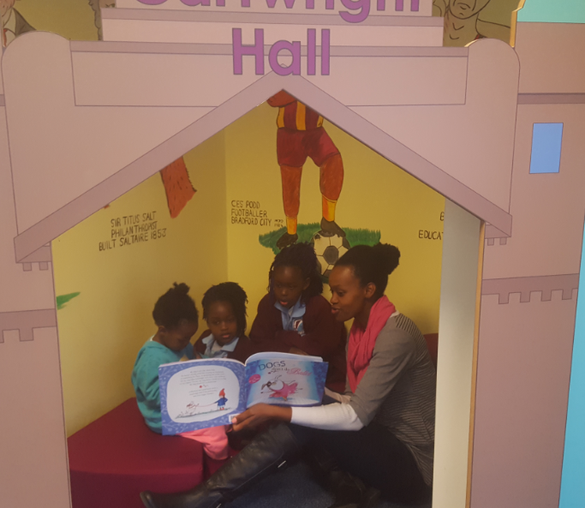
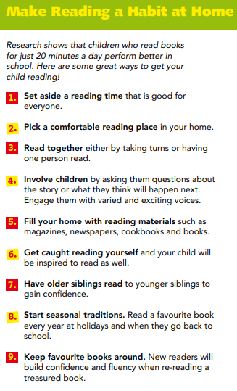
Top tips:

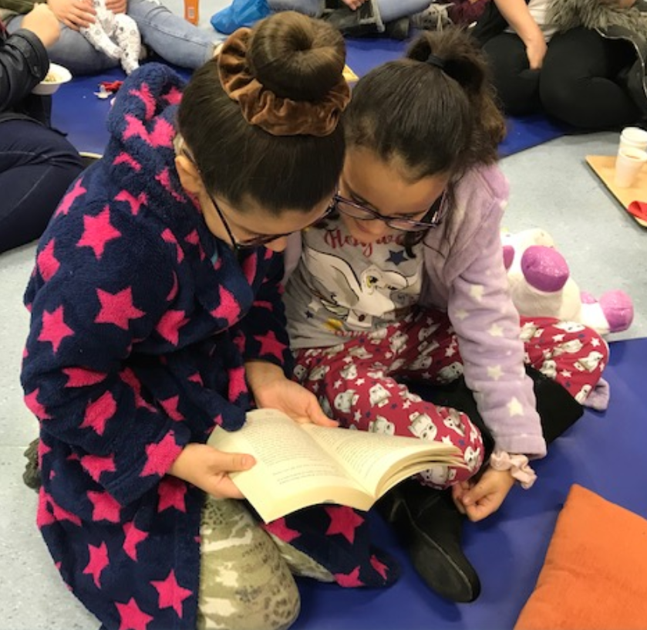
- Ask lots of questions about the book before reading, during and afterwards. Questions should range from literal retrieval of information to hypothesising about ‘whys’, possibilities and opinions.
- Try to hear your child read every day.
- Little and often is more beneficial than a long session once a week.
- Limit how long you are reading for - the amount of reading time should match your child’s span of attention.
- Choose your timing carefully - it’s best not to embark on a reading session when your child is tired.
- Mix lots of different types of book – an interest in a certain genre is brilliant but breadth and balance create a stronger reader in the long term.
- A bedtime story read by you or together is still the most valuable reading activity at home. Aim to model expression, voices, response to word layout or punctuation. Puzzle over events or actions together. Discuss the book together as partner story detectives!
Supporting early reading at home
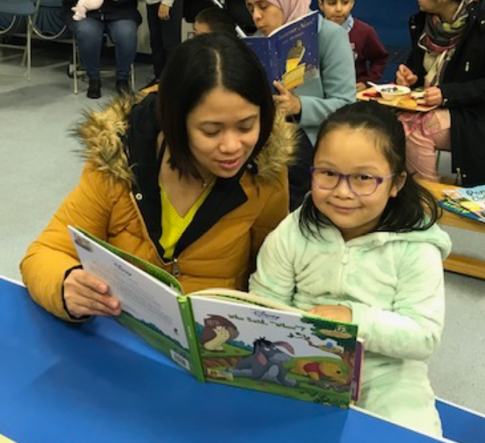
Questions to ask before reading:
• Can you point to the title? or What is this? (pointing to the title)
• What do you think this story might be about? What might happen in the story?
• What do we call the writing on the back of the book? (the blurb) or What does the blurb tell us?
During the reading of the book:
• What is happening in the pictures?
• What has happened so far? Is it what you expected to happen?
• What might happen next?
• How will the story end?
• Could there be another adventure after this one? What might the character do next?
• What sort of character is…?
• How could you describe him? (e.g. friendly, kind, mean etc.) Why?
At the end of the book:
• Did you like this book? Why? (Encourage your child to develop their opinion about books by encouraging them to explain their reasons.)
• What was your favourite part and why?
• What was the most exciting/interesting part of the book? Can you find it? Why have you picked this part?
• What sort of character was…..?
• Why did that character do….(give an event or action in the story)?
• What happened in the story?
Supporting an independent reader at home
Independent readers still need your support to develop as readers. There are ways to support independent readers at home.
• Discuss books with your child – try reading the same book so you can talk about it.
• Ask your child to prepare a section to read aloud to you.
• Encourage your child to ask you if they come across new words.
“Parents can instil a love of reading long before a child goes to school and deepen that love of reading as the child grows up.”
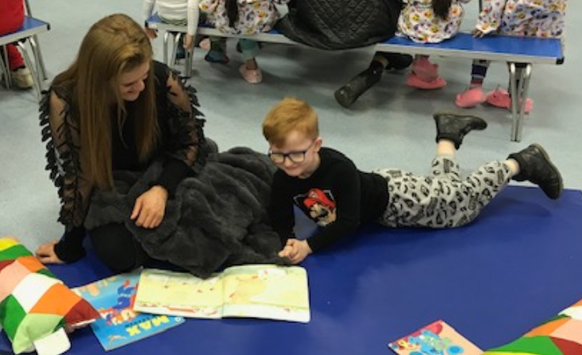
Foster a love of reading
• Read stories, poems and other texts aloud to your child.
• Let your child see you reading for purpose and pleasure.
• Visit the library / bookshops to choose their own books.
• Reading with siblings, older and younger.
• Use stories on CDs to follow.
• Follow your child’s interests.
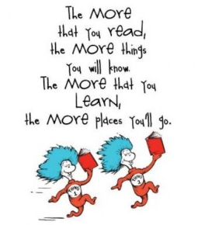
• Give reading a purpose - TV guide, recipes, game instructions, signs, catalogues…

