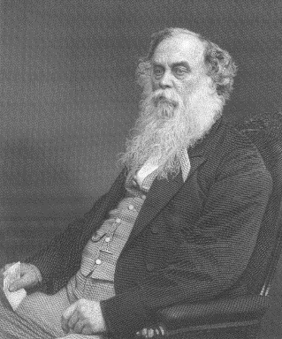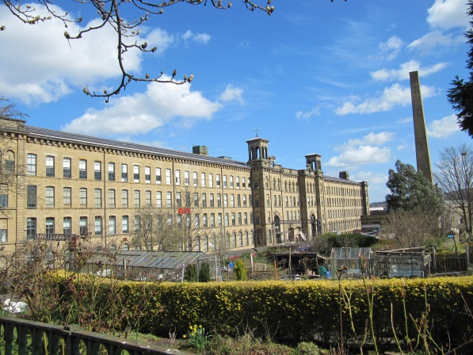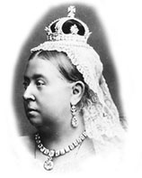

**Sir Titus Salt**

**Salts Mill**

Many buildings around Bradford remind us of the Victorian time. One of these is Salts Mill. Some interesting facts about Salts Mill are:

**What was life like in Victorian Britain?**

**How does the life of a Victorian child compare to a modern world child?**

**How did the Industrial Revolution change life in Britain? What legislation acts were brought in?**

The Victorians