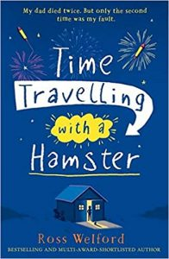
Time Travelling with a Hamster
p. 31 – 35
1. How does Grandpa Byron remember musical facts from 1969 all the way through to 2009?

2. Find and copy the phrase that tells you Al senses something strange is going on.

3. What do you predict the research Grandpa Byron disagreed with is going to be about?

